**React/Node.js/Jest/JS Code snippet**

Create-React-App to create folder structure.

npx create-react-app **app_name**

npm start

<https://github.com/aws/awsui-documentation>

[git clone https://github.com/ibm-developer-skills-network/lkpho-Cloud-applications-with-Node.js-and-React.git](git%20clone%20https:/github.com/ibm-developer-skills-network/lkpho-Cloud-applications-with-Node.js-and-React.git)

<https://scrimba.com/>

Part 1 - AWS UI Tutorial with React:-

[https://broadcast.amazon.com/videos/365496?query=AWS%20UI](%20https://broadcast.amazon.com/videos/365496?query=AWS%20UI)

Part 2 - AWS UI Tutorial with React <https://broadcast.amazon.com/videos/365497?ref=videos&src=related-videos>

Part 3 - AWS UI Tutorial with React

<https://broadcast.amazon.com/videos/365499?ref=videos&src=related-videos>

Part 4 - AWS UI Tutorial with React <https://broadcast.amazon.com/videos/365500?ref=videos&src=related-videos>

Cloudscape:- <https://cloudscape.aws.dev/get-started/dev-guides/collection-hooks/>

Cloudscape UI:- https://cloudscape.aws.dev/components/

Git Repos Blog:- <https://blog.stackademic.com/21-must-bookmark-react-github-repositories-every-react-developer-should-know-d88086a7b936>

Shortcut for react components:- <https://stackoverflow.com/questions/68653611/rafce-react-js-shortcut-not-working-in-vscode>

Medium Article:- <https://medium.com/@dev.shefali7>

Components:- <https://github.com/Chalarangelo/30-seconds-of-react/blob/master/snippets/use-delayed-state.md>

MDN:- [https://developer.mozilla.org/en-US/docs/Learn/Tools_and_testing/Client-side_JavaScript_frameworks/React_accessibility#focusing_between_templates](https://developer.mozilla.org/en-US/docs/Learn/Tools_and_testing/Client-side_JavaScript_frameworks/React_accessibility%23focusing_between_templates)

**Git :-** git clone <https://github.com/ibm-developer-skills-network/lkpho-Cloud-applications-with-Node.js-and-React.git>

**Change directory to folder:-** cd lkpho-Cloud-applications-with-Node.js-and-React/CD220Labs/expressjs/

**Web design Project :-** <https://github.com/Kunjan28/WebDesignProject/blob/master/frontend/src/services/auth.services.js>

**Git:-** [ ! -d 'nodejs_PracticeProject_AuthUserMgmt' ] && git clone https://github.com/ibm-developer-skills-network/nodejs_PracticeProject_AuthUserMgmt.git

React Testing Library:- <https://testing-library.com/docs/react-testing-library/intro/>

Chakra UI Link:- https://v2.chakra-ui.com/docs/hooks/use-boolean

**Map functions**

**Dessert.js**

Order should always be filter sort and map. Note that here sort isn’t used.

function DessertsList(props) {

  const dessert_var = props.data;

  const dessert_list = dessert_var.filter(dessert_item => {

    return dessert_item.calories < 500

  }).map(dessert_item => {

    const new_var = `${dessert_item.name} - ${dessert_item.calories}`

    return <li>{new_var}</li>

  });

  // Returning the list of items within a <ul> element

  return (

    <ul>

      {dessert_list}

    </ul>

  );

}

export default DessertsList;

**Apps.js**

import "./App.css";

import DessertsList from "./DessertsList";

const desserts = [

  {

    name: "Chocolate Cake",

    calories: 400,

    createdAt: "2022-09-01",

  },

  {

    name: "Ice Cream",

    calories: 200,

    createdAt: "2022-01-02",

  },

  {

    name: "Tiramisu",

    calories: 300,

    createdAt: "2021-10-03",

  },

  {

    name: "Cheesecake",

    calories: 600,

    createdAt: "2022-01-04",

  },

];

function App() {

  return (

    <div className="App">

      <h2>List of low calorie desserts:</h2>

      <DessertsList data={desserts} />

    </div>

  );

}

export default App;

**Index.js**

import React from 'react';

import ReactDOM from 'react-dom/client';

import './index.css';

import App from './App';

const root = ReactDOM.createRoot(document.getElementById('root'));

root.render(

  <React.StrictMode>

    <App />

  </React.StrictMode>

);

## About React Context:

## Application execution starts from App.js

## Main function App is being wrapped within ThemeProvider from ThemeContext folder or a file created.

* useContext(ThemeContext);

## Being called in all of the components of the application which could be maintained as a separate folder or may be in the same app

## current state or functions implemented in ThemeContext is then used within different components

## In below example page, header, content, Paragraph is considered as different components

## Theme and Toggle function is implemented in ThemeContext and controlled through switch.js, then theme is being used in all of the components and it’s state being changed and shared.

## Based upon the theme value which is light and dark, the style of components such as header, content, paragraph etc is getting changed for given theme condition.

## App.js:

import "./App.css";

import { ThemeProvider, useTheme } from "./ThemeContext";

import Switch from "./Switch";

const Title = ({ children }) => {

  const { theme } = useTheme();

  return (

    <h2

      style={{

        color: theme === "light" ? "black" : "white",

      }}

    >

      {children}

    </h2>

  );

};

const Paragraph = ({ children }) => {

  const { theme } = useTheme();

  return (

    <p

      style={{

        color: theme === "light" ? "black" : "white",

      }}

    >

      {children}

    </p>

  );

};

const Content = () => {

  return (

    <div>

      <Paragraph>

        We are a pizza loving family. And for years, I searched and searched and

        searched for the perfect pizza dough recipe. I tried dozens, or more.

        And while some were good, none of them were that recipe that would

        make me stop trying all of the others.

      </Paragraph>

    </div>

  );

};

const Header = () => {

  return (

    <header>

      <Title>Little Lemon 🍕</Title>

      <Switch />

    </header>

  );

};

const Page = () => {

  return (

    <div className="Page">

      <Title>When it comes to dough</Title>

      <Content />

    </div>

  );

};

function App() {

  const { theme } = useTheme();

  return (

    <div

      className="App"

      style={{

        backgroundColor: theme === "light" ? "white" : "black",

      }}

    >

      <Header />

      <Page />

    </div>

  );

}

function Root() {

  return (

    <ThemeProvider>

      <App />

    </ThemeProvider>

  );

}

export default Root;

## 

## ThemeContext.js

import React, { useState, createContext, useContext } from "react";

const ThemeContext = createContext();

export const ThemeProvider = ({ children }) => {

  const [theme, setTheme] = useState("light");

  const toggleTheme = () => {

    setTheme((prevTheme) => (prevTheme === "light" ? "dark" : "light"));

  };

  return (

    <ThemeContext.Provider value={{ theme, toggleTheme }}>

      {children}

    </ThemeContext.Provider>

  );

};

export const useTheme = () => {

  return useContext(ThemeContext);

};

**Switch.js**

import React from "react";

import "./Styles.css";

import { useTheme } from "../ThemeContext";

const Switch = () => {

  const { theme, toggleTheme } = useTheme();

  return (

    <label className="switch">

      <input

        type="checkbox"

        checked={theme === "light"}

        onChange={toggleTheme}

      />

      <span className="slider round" />

    </label>

  );

};

export default Switch;

Button Disable onSubmit:-

import { useState } from "react";

export default function App() {

  const [giftCard, setGiftCard] = useState(

    {

        firstName: "Jennifer",

        lastName: "Smith",

        text: "Free dinner for 4 guests",

        valid: true,

        instructions: "To use your coupon, click the button below.",

    }

  );

  function spendGiftCard() {

    const newGreeting = { ...giftCard };

    newGreeting.text = 'Your coupon has been used.'

    newGreeting.instructions = "Please visit our restaurant to renew your gift card."

    newGreeting.valid = false

    setGiftCard(newGreeting);

  }

  return (

    <div style={{padding: '40px'}}>

      <h1>

        Gift Card Page

      </h1>

      <h2>

        Customer: {giftCard.firstName} {giftCard.lastName}

      </h2>

      <h3>

        {giftCard.text}

      </h3>

      <p>

        {giftCard.instructions}

      </p>

      {

        giftCard.valid && (

          <button onClick={spendGiftCard}>

            Spend Gift Card

          </button>

        )

      }

    </div>

  );

}

**Usestate Hooks invocation: -**

Const[cars, setcars] = usestate({color: ‘blue’, age:22}) – Initial state

setCars(prev => ({…prev, age:24}))

Fetch Data example:-

import React from "react";

function App() {

  const [user, setUser] = React.useState([]);

  const fetchData = () => {

    fetch("https://randomuser.me/api/?results=1")

      .then((response) => response.json())

      .then(data => setUser(data))

  };

  React.useEffect(() => {

    fetchData();

  }, []);

  return Object.keys(user).length > 0 ? (

    <div style={{padding: "40px"}}>

      <h1>Customer data</h1>

      <h2>First Name:{user.results[0].name.first}</h2>

      <h2>Last  Name:{user.results[0].name.last}</h2>

      <img src={user.results[0].picture.large} alt=""></img>

    </div>

  ) : (

    <h1>Data pending...</h1>

  );

}

export default App;

**Drop Down Option Edit:-**

Refer your replit notebook – ReactDemo

YouTube Channel by Sanjeev for :- <https://www.youtube.com/watch?v=u6gSSpfsoOQ&t=26722s>

const renderDropdown = () => {

  const dropDownClass = search ? "show" : null

  return (

    <ul style={{

      height: "500px",

      overflowY: "scroll",

      overflowX: "hidden",

      cursor: "pointer"

    }} className={`dropdown-menu ${dropDownClass}`}>

      {results.map((result) => {

        return (

          <li onClick={() => {

            addStock(result.symbol)

            setSearch("")

          }} key={result.symbol} className="dropdown-item">{result.description} ({result.symbol})</li>

        )

      })}

qq

**Fetch and Promise examples:-**

const fetchPromise1 = fetch(

  "https://mdn.github.io/learning-area/javascript/apis/fetching-data/can-store/products.json",

);

const fetchPromise2 = fetch(

  "https://mdn.github.io/learning-area/javascript/apis/fetching-data/can-store/not-found",

);

const fetchPromise3 = fetch(

  "bad-scheme://mdn.github.io/learning-area/javascript/oojs/json/superheroes.json",

);

Promise.all([fetchPromise1, fetchPromise2, fetchPromise3])

  .then((responses) => {

    for (const response of responses) {

      console.log(`${response.url}: ${response.status}`);

    }

  })

  .catch((error) => {

    console.error(`Failed to fetch: ${error}`);

  });

**Async function and execution order:-**

async function concurrent1() {

  console.log("== concurrent1 starts ==");

  // 1. Start two timers concurrently and wait for both to complete

  const results = await Promise.all([

    resolveAfter2Seconds(),

    resolveAfter1Second(),

  ]);

  // 2. Log the results together

  console.log(results[0]);

  console.log(results[1]);

  console.log("== concurrent1 done ==");

}

async function concurrent2() {

  console.log("== concurrent2 starts ==");

  // 1. Start two timers concurrently, log immediately after each one is done

  await Promise.all([

    (async () => console.log(await resolveAfter2Seconds()))(),

    (async () => console.log(await resolveAfter1Second()))(),

  ]);

  console.log("== concurrent2 done ==");

}

sequentialStart(); // after 2 seconds, logs "slow", then after 1 more second, "fast"

// wait above to finish

setTimeout(sequentialWait, 4000); // after 2 seconds, logs "slow" and then "fast"

// wait again

setTimeout(concurrent1, 7000); // same as sequentialWait

// wait again

setTimeout(concurrent2, 10000); // after 1 second, logs "fast", then after 1 more second, "slow"

**App.js:-**

**UseReducer VS Usestate:**

UseState is used for less complex applications which involves lesser numbers of state changes while UseReducer is used for more complex applications.

Another example of UseState would be toggling a variable on or off as it has limited numbers of states.

Example to increase a count you can simply use UseState while UseReducer is used for Increase, Decrease the counts of the given application.

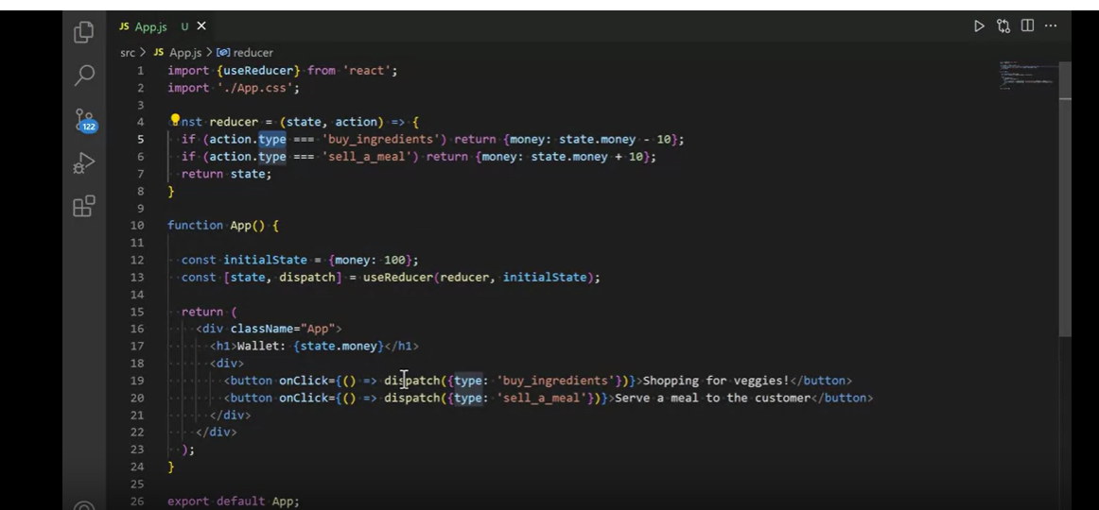

Another example of Usereducer function:-

**Location.Js**

import React, { useContext } from 'react';

import { AppContext } from '../context/AppContext';

const Location = () => {

  const {dispatch } = useContext(AppContext);

    const changeLocation = (val)=>{

            dispatch({

                type: 'CHG_LOCATION',

                payload: val,

            })

    }

  return (

        <div className='alert alert-secondary'> Location {

      <select name="Location" id="Location" onChange={event=>changeLocation(event.target.value)}>

        <option value="£">Uk(£)</option>

        <option value="₹">India(₹)</option>

        <option value="€">Europe(€)</option>

        <option value="CAD">Canada(CAD)</option>

      </select>

      }

    </div>

    );

};

**AppContext.js:**

       case 'DELETE_ITEM':

            state.expenses.map((expense)=>{

                if(expense.name === action.payload.name) {

                    expense.quantity = 0;

                }

                new_expenses.push(expense);

                return true;

            })

            state.expenses = new_expenses;

            action.type = "DONE";

            return {

                ...state,

            };

    case 'CHG_LOCATION':

            action.type = "DONE";

            state.Location = action.payload;

            return {

                ...state

            }

        default:

            return state;

    }

};

**Holding Previous State of an application using UseRef Function:-**

**Define a ref cursor using useRef and use it along with useEffect.**

import { useState, useEffect, useRef } from "react";

export default function App() {

  const [day, setDay] = useState("Monday");

  const prevDay = usePrevious(day);

  const getNextDay = () => {

    if (day === "Monday") {

      setDay("Tuesday")

    } else if (day === "Tuesday") {

      setDay("Wednesday")

    } else if (day === "Wednesday") {

      setDay("Thursday")

    } else if (day === "Thursday") {

      setDay("Friday")

    } else if (day === "Friday") {

      setDay("Monday")

    }

  }

  return (

    <div style={{padding: "40px"}}>

      <h1>

        Today is: {day}<br />

        {

          prevDay && (

            <span>Previous work day was: {prevDay}</span>

          )

        }

      </h1>

      <button onClick={getNextDay}>

        Get next day

      </button>

    </div>

  );

}

function usePrevious(val) {

  const ref = useRef();

  useEffect(() => {

    ref.current = val;

  }, [val]);

  return ref.current;

}

**UseRef:-**

import React, { useState, useEffect, useRef } from 'react';

function Counter() {

    const [count, setCount] = useState(0);

    const prevCountRef = useRef();

    useEffect(() => {

        prevCountRef.current = count;

    }, [count]);

    const prevCount = prevCountRef.current;

    return (

        <div>

            <p>Current Count: {count}</p>

            <p>Previous Count: {prevCount}</p>

            <button onClick={() => setCount(count + 1)}>Increment</button>

        </div>

    );

}

export default Counter;

**React Component composition with children:-**

You can create a parent component which has some common logic which will be applicable to it’s child components. Child components will be wrapped in the parent components and you have to declare and variable to represent child component while writing a parent component.

**Examlpe:-**

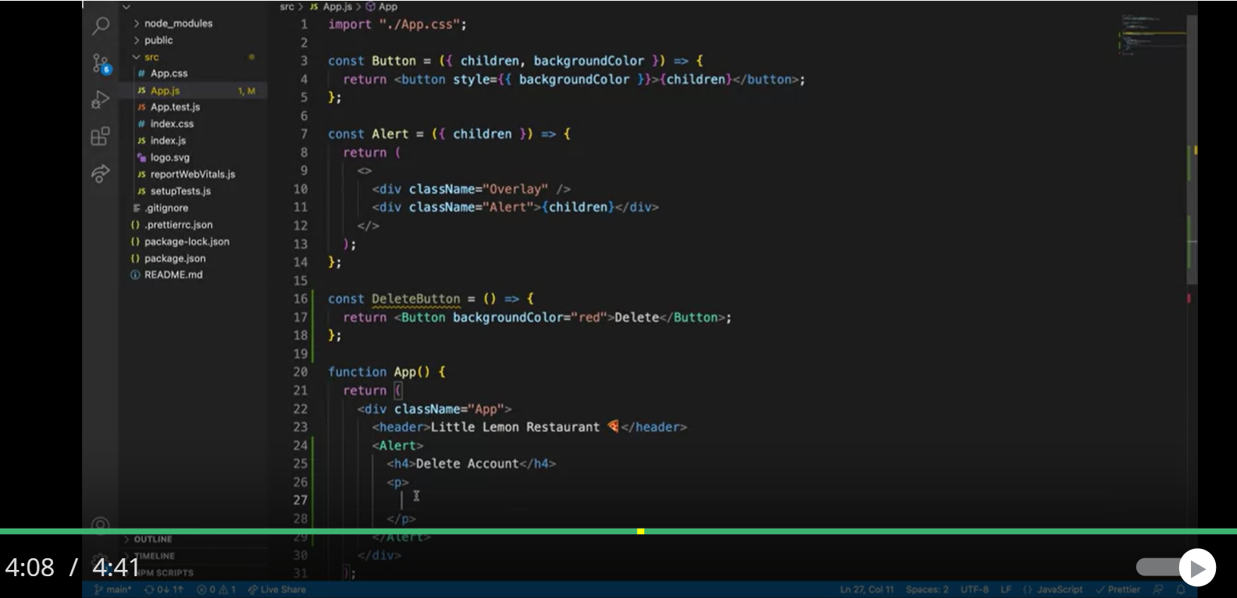

**Container Component:-**

import React from 'react';

const Container = ({ children }) => {

    return (

        <div style={{ border: '1px solid #ccc', padding: '20px', borderRadius: '5px' }}>

            {children}

        </div>

    );

};

export default Container;

**List of components:-**

--Headercomponent

import React from 'react';

const Header = ({ title }) => {

    return <h1>{title}</h1>;

};

export default Header;

--ContentComponent

import React from 'react';

const Content = ({ text }) => {

    return <p>{text}</p>;

};

export default Content;

--FooterComponent

import React from 'react';

const Footer = ({ text }) => {

    return <footer>{text}</footer>;

};

export default Footer;

**App.js**

import React from 'react';

import Container from './Container';

import Header from './Header';

import Content from './Content';

import Footer from './Footer';

const App = () => {

    return (

        <Container>

            <Header title="Welcome to My App" />

            <Content text="This is the main content of the app." />

            <Footer text="© 2024 My App" />

        </Container>

    );

};

export default App;

**React Child Components:-**

To apply property to all of its child components based on indexes. This is similar to map function in react but consider it as map components. 7

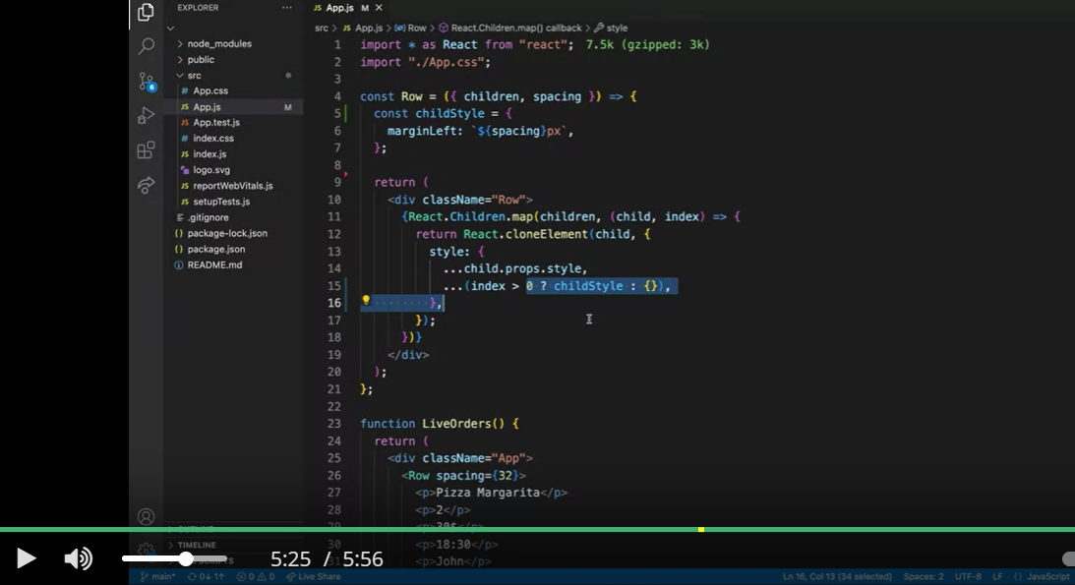

**New example :-**

**App.js**

import "./App.css";

import { RadioGroup, RadioOption } from "./Radio";

import { useState } from "react";

function App() {

  const [selected, setSelected] = useState("");

  return (

    <div className="App">

      <h2>How did you hear about Little Lemon?</h2>

      <RadioGroup onChange={setSelected} selected={selected}>

        <RadioOption value="social_media">Social Media</RadioOption>

        <RadioOption value="friends">Friends</RadioOption>

        <RadioOption value="advertising">Advertising</RadioOption>

        <RadioOption value="other">Other</RadioOption>

      </RadioGroup>

      <button disabled={!selected}>Submit</button>

    </div>

  );

}

export default App;

**Index.js**

**RadioGroup has two variables and a children components which are onchange, selected and children**

**RadioOptions has three variables and a children component which are onchange, selected, children**

**and value. Note that in radio option onchange is nothing but set selected function.**

import * as React from "react";

import "./styles.css";

export const RadioGroup = ({ onChange, selected, children }) => {

  // Use React.Children.map and React.cloneElement to clone the children

  // and pass the correct props to each RadioOption

  const RadioOptions = React.Children.map(children, (child) => {

    return React.cloneElement(child, {

      onChange,

      checked: child.props.value === selected,

    });

  });

  return <div className="RadioGroup">{RadioOptions}</div>;

};

export const RadioOption = ({ value, checked, onChange, children }) => {

  // Hook up the onChange handler to call the onChange prop passed to RadioGroup

  // Also, make sure to pass the correct checked prop to the input element

  return (

    <div className="RadioOption">

      <input id={value}

        type="radio"

        name={value}

        value={value}

        checked={checked}

        onChange={(e) => {

          onChange(e.target.value);

        }}

      />

      <label htmlFor={value}>{children}</label>

    </div>

  );

};

Spread Attributes:-

**Combining Objects:-**

const obj1 = { a: 1, b: 2 };

const obj2 = { c: 3, d: 4 };

const combined = { ...obj1, ...obj2 };

console.log(combined); // Output: { a: 1, b: 2, c: 3, d: 4 }

**Copying Objects:-**

const original = { a: 1, b: 2 };

const copy = { ...original };

console.log(copy); // Output: { a: 1, b: 2 }

**Adding/Overwriting/Merging Properties:-**

const obj = { a: 1, b: 2 };

const updated = { ...obj, b: 3, c: 4 };

console.log(updated); // Output: { a: 1, b: 3, c: 4 }

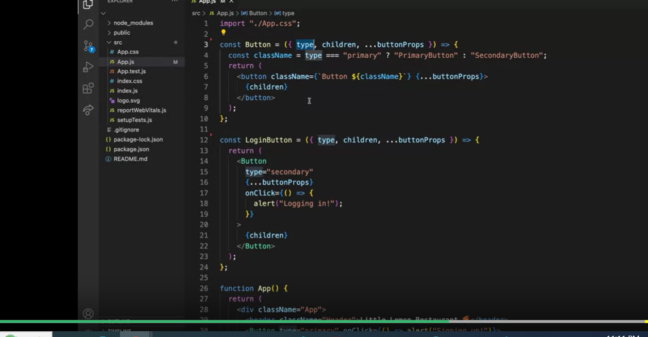

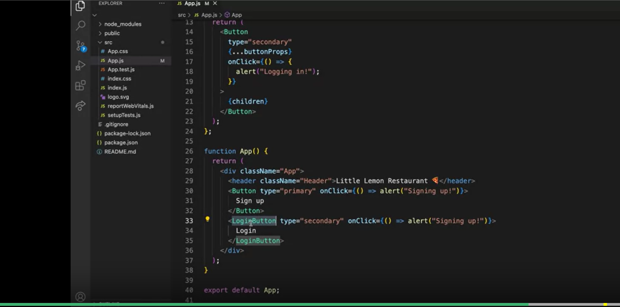

**JSX**

Let’s suppose you have the below JSX that gets returned from a component, what would be the equivalent object representation (Element) that React will create internally?

<button className='button-primary'>

<div>

Submit

</div>

</button>

{

    type: "button",

    props: {

        className: "button-primary",

        children: {

            type: "div",

            props: {

                children: "Submit",

            }

        },

    },

}

React Fragment example:-

import React from 'react';

import ReactDOM from 'react-dom';

function Glossary(props) {

  return (

    <dl>

      {props.items.map(item => (

        // Without the `key`, React will fire a key warning

        <React.Fragment key={item.id}>

          <dt>{item.term}</dt>

          <dd>{item.description}</dd>

        </React.Fragment>

      ))}

    </dl>

  );

}

const glossaryItems = [

  { id: 1, term: 'React', description: 'A JavaScript library for building user interfaces.' },

  { id: 2, term: 'JavaScript', description: 'A programming language used for web development.' },

  { id: 3, term: 'Component', description: 'Reusable building blocks in React.' }

];

ReactDOM.render(<Glossary items={glossaryItems} />, document.getElementById('root'));

**Tic-Tac-Toe in React**

Time Travel and history tracking is pending here.

History tracking on React Application:- https://legacy.reactjs.org/tutorial/tutorial.html#adding-time-travel

**Components:-**

1. **Board**:- Has all of its elements
2. **Square**:- Is 9 elements object. With initial state as null in all the places.
3. **Turns**:- Two player game player one is X player two is O. This is basic assumption. Implemented through IsNext variable.
4. **Winner**:- Found combination of all of the winning positions and match it with current state of the square.
5. **Handle-click**:- Is implemented at each of those clicks at each position.

function Square(props) {

    return (

      <button className="square" onClick={props.onClick}>

        {props.value}

        /* This would create the board to work with checkout className*/

      </button>

    );

  }

class Board extends React.Component{

    constructor(props) {

        super(props);

        this.state = {

            sqaures: Array(9).fill(null),

            xIsNext: true,

        };

    }

    handleClick(i){

        /*Slice is to copy and create a new element*/

        const sqaures = this.state.sqaures.slice()

        sqaures[i] = this.state.xIsNext ? 'X' : 'O';

        /*Set the state of current execution*/

        this.setState({sqaures: sqaures,

            xIsNext: !this.state.xIsNext,

        });

    }

    rendersqaure(i){

        return (

            <Sqaure

                value={this.state.sqaures[i]}

                onClick={() => this.handleClick(i)}

            />

        )

    }

    render(){

        /* Note that here we are passing the state of entire sqaure*/

        const winner = calculateWinner(this.state.sqaures)

        let status;

        if (winner) {

            status = 'Winner: ' + winner;

         }else{

            status = 'Next player: ' + (this.state.xIsNext ? 'X' : 'O');

        }

        return(

            <div>

                <div className="status">{status}</div>

                <div className="board-row">

                    {this.rendersqaure(0)}

                    {this.rendersqaure(1)}

                    {this.rendersqaure(2)}

                </div>

                <div className="board-row">

                    {this.rendersqaure(3)}

                    {this.rendersqaure(4)}

                    {this.rendersqaure(5)}

                </div>

                <div className="board-row">

                    {this.rendersqaure(6)}

                    {this.rendersqaure(7)}

                    {this.rendersqaure(8)}

                </div>

            </div>

        );

    }

}

class Game extends React.Component {

    render() {

      return (

        <div className="game">

          <div className="game-board">

            <Board />

          </div>

          <div className="game-info">

            <div>{/* status */}</div>

            <ol>{/* TODO */}</ol>

          </div>

        </div>

      );

    }

  }

  // ========================================

  const root = ReactDOM.createRoot(document.getElementById("root"));

  root.render(<Game />);

/* Winner Function */

function calculateWinner(){

    const lines = [

        [0, 1, 2],

        [3, 4, 5],

        [6, 7, 8],

        [0, 3, 6],

        [1, 4, 7],

        [2, 5, 8],

        [0, 4, 8],

        [2, 4, 6],

    ];

/* Above is the list of combinations where there is  win. Positions would be passed to

sqaure to get the value at sqaure*/

    for (let i=0; i <lines.length; i++){

        const [a,b,c] = lines[i];

        if(sqaures[a] && sqaures[a] == sqaures[b] && sqaures[a]== sqaures[c]){

            return sqaures[a];

        }

    }

    return null;

}

**Notes on compound components:-**

**Link**:- <https://kentcdodds.com/blog/compound-components-with-react-hooks>

**Higher Order Components:-**

<https://www.freecodecamp.org/news/higher-order-components-in-react/>

**Render Properties:-**

Passing the current/local state of data as a parameters to render function.

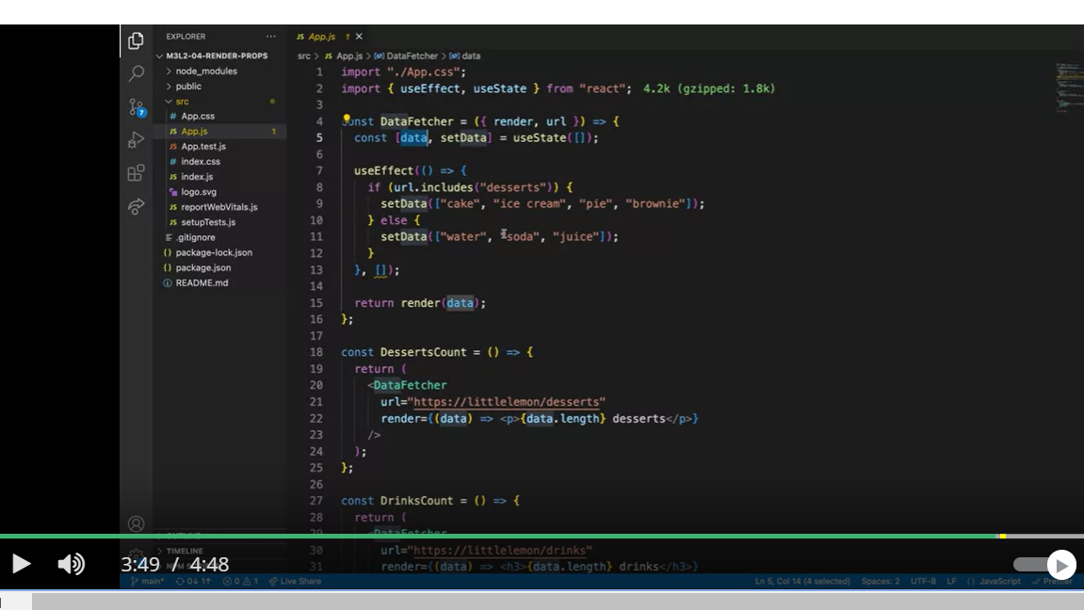

MousePosition With render Props:-

import "./App.css";

import { useEffect, useState } from "react";

const MousePosition = ({ render }) => {

  const [mousePosition, setMousePosition] = useState({

    x: 0,

    y: 0,

  });

  useEffect(() => {

    const handleMousePositionChange = (e) => {

      setMousePosition({

        x: e.clientX,

        y: e.clientY,

      });

    };

    window.addEventListener("mousemove", handleMousePositionChange);

    return () => {

      window.removeEventListener("mousemove", handleMousePositionChange);

    };

  }, []);

  return render({ mousePosition });

};

const PanelMouseLogger = () => {

  return (

    <div className="BasicTracker">

      <p>Mouse position:</p>

      <MousePosition

        render={({ mousePosition }) => (

          <div className="Row">

            <span>x: {mousePosition.x}</span>

            <span>y: {mousePosition.y}</span>

          </div>

        )}

      />

    </div>

  );

};

const PointMouseLogger = () => {

  return (

    <MousePosition

      render={({ mousePosition }) => (

        <p>

          ({mousePosition.x}, {mousePosition.y})

        </p>

      )}

    />

  );

};

function App() {

  return (

    <div className="App">

      <header className="Header">Little Lemon Restaurant 🍕</header>

      <PanelMouseLogger />

      <PointMouseLogger />

    </div>

  );

}

export default App;

**ComponentWillMount and ComponentDidMount:-**

In this example:

1. **Mounting:**
   * When the App component is first rendered, this.state.showClock is true, so the Clock component is rendered and its componentDidMount method is called, setting up the interval.
2. **Unmounting:**
   * When you click the "Toggle Clock" button, toggleClock changes the state to showClock: false, causing the Clock component to be removed from the DOM.
   * Before the Clock component is removed, its componentWillUnmount method is called, clearing the interval timer.

class Clock extends React.Component {

    constructor(props) {

      super(props);

      this.state = {date: new Date()};

    }

    componentDidMount() {

      this.timerID = setInterval(

        () => this.tick(),

        1000

      );

    }

    componentWillUnmount() {

      clearInterval(this.timerID);

    }

    tick() {

      this.setState({

        date: new Date()

      });

    }

    render() {

      return (

        <div>

          <h1>Hello, world!</h1>

          <h2>It is {this.state.date.toLocaleTimeString()}.</h2>

        </div>

      );

    }

  }

  const root = ReactDOM.createRoot(document.getElementById('root'));

  root.render(<Clock />);

  class App extends React.Component {

    constructor(props) {

      super(props);

      this.state = { showClock: true };

    }

    toggleClock = () => {

      this.setState(state => ({ showClock: !state.showClock }));

    }

    render() {

      return (

        <div>

          <button onClick={this.toggleClock}>

            Toggle Clock

          </button>

          {this.state.showClock && <Clock />}

        </div>

      );

    }

  }

  const root = ReactDOM.createRoot(document.getElementById('root'));

  root.render(<App />);

Checkbox Selection code with API call and pagination:-

import React, { useState, useEffect } from 'react';

function CheckboxForm() {

  const [items, setItems] = useState([]);

  const [selectedItems, setSelectedItems] = useState([]);

  const [currentPage, setCurrentPage] = useState(1);

  const [totalPages, setTotalPages] = useState(1);

  const [resultsPerPage, setResultsPerPage] = useState(10); // Default to 10 items per page

  useEffect(() => {

    fetchItems(currentPage, resultsPerPage);

  }, [currentPage, resultsPerPage]);

  const fetchItems = async (page, limit) => {

    try {

      const response = await fetch(`http://localhost:5000/api/items?page=${page}&limit=${limit}`);

      const data = await response.json();

      setItems(data.items);

      setTotalPages(data.totalPages);

    } catch (error) {

      console.error('Error fetching items:', error);

    }

  };

  const handleCheckboxChange = (event) => {

    const value = event.target.value;

    if (event.target.checked) {

      setSelectedItems([...selectedItems, value]);

    } else {

      setSelectedItems(selectedItems.filter((item) => item !== value));

    }

  };

  const handleSubmit = (event) => {

    event.preventDefault();

    alert(`You selected: ${selectedItems.length ? selectedItems.join(', ') : 'No items selected'}`);

  };

  const handlePageChange = (page) => {

    setCurrentPage(page);

  };

  const handleResultsPerPageChange = (event) => {

    setResultsPerPage(parseInt(event.target.value));

    setCurrentPage(1); // Reset to the first page whenever results per page change

  };

  return (

    <div>

      <h2>Select Items</h2>

      <form onSubmit={handleSubmit}>

        {items.map((item, index) => (

          <label key={index}>

            <input

              type="checkbox"

              value={item.name}

              onChange={handleCheckboxChange}

            />

            {item.name}

          </label>

        ))}

        <br /><br />

        <button type="submit">Submit</button>

      </form>

      <p>{selectedItems.length ? `You selected: ${selectedItems.join(', ')}` : 'No items selected'}</p>

      <div>

        <label>

          Results per page:

          <select value={resultsPerPage} onChange={handleResultsPerPageChange}>

            <option value={5}>5</option>

            <option value={10}>10</option>

            <option value={20}>20</option>

            <option value={50}>50</option>

          </select>

        </label>

      </div>

      <div>

        <button

          onClick={() => handlePageChange(currentPage - 1)}

          disabled={currentPage === 1}

        >

          Previous

        </button>

        <span> Page {currentPage} of {totalPages} </span>

        <button

          onClick={() => handlePageChange(currentPage + 1)}

          disabled={currentPage === totalPages}

        >

          Next

        </button>

      </div>

    </div>

  );

}

export default CheckboxForm;

Hide from UI:- Visible option

import React, { useState } from 'react';

function App() {

  // State to track the visibility of the item

  const [isVisible, setIsVisible] = useState(true);

  // Function to handle the remove action

  const handleRemove = () => {

    setIsVisible(false); // Set visibility to false when "Remove" is clicked

  };

  return (

    <div className="App">

      {isVisible && (

        <div>

          <p>This is the item you want to hide.</p>

          <button onClick={handleRemove}>Remove</button>

        </div>

      )}

    </div>

  );

}

export default App;

**React Router Examples:-**

Link- <https://stackoverflow.com/questions/63124161/attempted-import-error-switch-is-not-exported-from-react-router-dom>

Help:- <https://v5.reactrouter.com/web/example/recursive-paths>

//Nested Routes

// src/App.js

import React from 'react';

import { BrowserRouter as Router, Route, Routes, Link } from 'react-router-dom';

import Home from './Home';

import About from './About';

import Contact from './Contact';

import Team from './Team'; // New nested component

function App() {

  return (

    <Router>

      <div>

        <nav>

          <ul>

            <li>

              <Link to="/">Home</Link>

            </li>

            <li>

              <Link to="/about">About</Link>

            </li>

            <li>

              <Link to="/contact">Contact</Link>

            </li>

            <li>

              <Link to="/about/team">Our Team</Link>

            </li>

          </ul>

        </nav>

        <Routes>

          <Route path="/" element={<Home />} />

          <Route path="/about" element={<About />}>

            <Route path="team" element={<Team />} />

          </Route>

          <Route path="/contact" element={<Contact />} />

          <Route path="*" element={<NotFound />} /> {/* Catch-all route */}

          <Route path="/navigate" element={<NavigatePage />} />

        </Routes>

      </div>

    </Router>

  );

}

function NavigatePage() {

    const navigate = useNavigate();

    const handleClick = () => {

      navigate('/about');

    };

    return (

      <div>

        <h2>Navigate Page</h2>

        <button onClick={handleClick}>Go to About Page</button>

      </div>

    );

  }

export default App;

// src/About.js

import React from 'react';

function About() {

  return (

    <div>

      <h2>About Page</h2>

      <p>This is the about page.</p>

    </div>

  );

}

export default About;

// src/Home.js

import React from 'react';

function Home() {

  return (

    <div>

      <h2>Home Page</h2>

      <p>Welcome to the home page!</p>

    </div>

  );

}

export default Home;

// src/Contact.js

import React from 'react';

function Contact() {

  return (

    <div>

      <h2>Contact Page</h2>

      <p>Get in touch with us here.</p>

    </div>

  );

}

export default Contact;

// src/Team.js

import React from 'react';

function Team() {

  return (

    <div>

      <h3>Our Team</h3>

      <p>Meet our amazing team!</p>

    </div>

  );

}

export default Team;

// src/NotFound.js

import React from 'react';

function NotFound() {

  return (

    <div>

      <h2>404 - Page Not Found</h2>

      <p>Sorry, the page you are looking for does not exist.</p>

    </div>

  );

}

export default NotFound;

**DateRangePicker Examples:-**

**Step 1:-**

npm install react-daterange-picker

**Step 2:** Import and Use the Date Range Picker

import React, { useState } from 'react';

import DateRangePicker from 'react-daterange-picker';

import 'react-daterange-picker/dist/styles.css'; // Main css file

function App() {

  const [dateRange, setDateRange] = useState([null, null]);

  const handleDateChange = (range) => {

    setDateRange(range);

  };

  return (

    <div>

      <h1>Select Date Range</h1>

      <DateRangePicker

        onChange={handleDateChange}

        value={dateRange}

      />

      {dateRange[0] && dateRange[1] && (

        <div>

          <p>Start Date: {dateRange[0].toLocaleDateString()}</p>

          <p>End Date: {dateRange[1].toLocaleDateString()}</p>

        </div>

      )}

    </div>

  );

}

export default App;

**HOC**

import React, { Component } from 'react'

import ReactDOM from 'react-dom'

const Button = ({ onClick, text, style }) => {

  return (

    <button onClick={onClick} style={style}>

      {text}

    </button>

  )

}

const buttonWithStyles = (CompParam, name = 'default') => {

  const colors = [

    {

      name: 'default',

      backgroundColor: '#e7e7e7',

      color: '#000000',

    },

    {

      name: 'react',

      backgroundColor: '#61dbfb',

      color: '#ffffff',

    },

    {

      name: 'success',

      backgroundColor: '#4CAF50',

      color: '#ffffff',

    },

    {

      name: 'info',

      backgroundColor: '#2196F3',

      color: '#ffffff',

    },

    {

      name: 'warning',

      backgroundColor: '#ff9800',

      color: '#ffffff',

    },

    {

      name: 'danger',

      backgroundColor: '#f44336',

      color: '#ffffff',

    },

  ]

  const { backgroundColor, color } = colors.find((c) => c.name === name)

  const buttonStyles = {

    backgroundColor,

    padding: '10px 45px',

    border: 'none',

    borderRadius: 3,

    margin: 3,

    cursor: 'pointer',

    fontSize: '1.25rem',

    color,

  }

  return (props) => {

    return <CompParam {...props} style={buttonStyles} />

  }

}

const NewButton = buttonWithStyles(Button)

const ReactButton = buttonWithStyles(Button, 'react')

const InfoButton = buttonWithStyles(Button, 'info')

const WarningButton = buttonWithStyles(Button, 'warning')

const DangerButton = buttonWithStyles(Button, 'danger')

const SuccessButton = buttonWithStyles(Button, 'success')

class App extends Component {

  render() {

    return (

      <div className='App'>

        <h1>Higher Order Components</h1>

        <Button text='No Style' onClick={() => alert('I am not styled yet')} />

        <NewButton

          text='Styled Button'

          onClick={() => alert('I am the default style')}

        />

        <ReactButton text='React' onClick={() => alert('I have react color')} />

        <InfoButton

          text='Info'

          onClick={() => alert('I am styled with info color')}

        />

        <SuccessButton text='Success' onClick={() => alert('I am successful')} />

        <WarningButton

          text='Warning'

          onClick={() => alert('I warn you many times')}

        />

        <DangerButton

          text='Danger'

          onClick={() => alert('Oh no, you can not restore it')}

        />

      </div>

    )

  }

}

const rootElement = document.getElementById('root')

ReactDOM.render(<App />, rootElement)

**React Router:-**

import React from 'react';

import { BrowserRouter as Router, Route, Switch, Link } from 'react-router-dom';

import Home from './Home';

import About from './About';

import Profile from './Profile';

import NotFound from './NotFound';

function App() {

  return (

    <Router>

      <nav>

        <ul>

          <li><Link to="/">Home</Link></li>

          <li><Link to="/about">About</Link></li>

          <li><Link to="/profile/1">Profile 1</Link></li>

          <li><Link to="/profile/2">Profile 2</Link></li>

        </ul>

      </nav>

      <Switch>

        <Route exact path="/" component={Home} />

        <Route path="/about" component={About} />

        <Route path="/profile/:id" component={Profile} />

        <Route component={NotFound} />

      </Switch>

    </Router>

  );

}

export default App;

**PasswordRevealer**

//PasswordRevealer

import React from 'react';

const PasswordRevealer = ({ value, onChange }) => {

  const [shown, setShown] = React.useState(false);

  return (

    <>

      <input

        type={shown ? 'text' : 'password'}

        value={value}

        onChange={onChange}

      />

      <button type="button" onClick={() => setShown(!shown)}>

        {shown ? 'Hide' : 'Show'}

      </button>

    </>

  );

};

export default PasswordRevealer;

//PasswordRevealer is being called here

import React, { useState } from 'react';

import PasswordRevealer from './PasswordRevealer';

function App() {

  const [password, setPassword] = useState('');

  const handlePasswordChange = (e) => {

    setPassword(e.target.value);

  };

  return (

    <div>

      <h1>Password Revealer Example</h1>

      <PasswordRevealer value={password} onChange={handlePasswordChange} />

    </div>

  );

}

export default App;

**Range Input:- npm test**

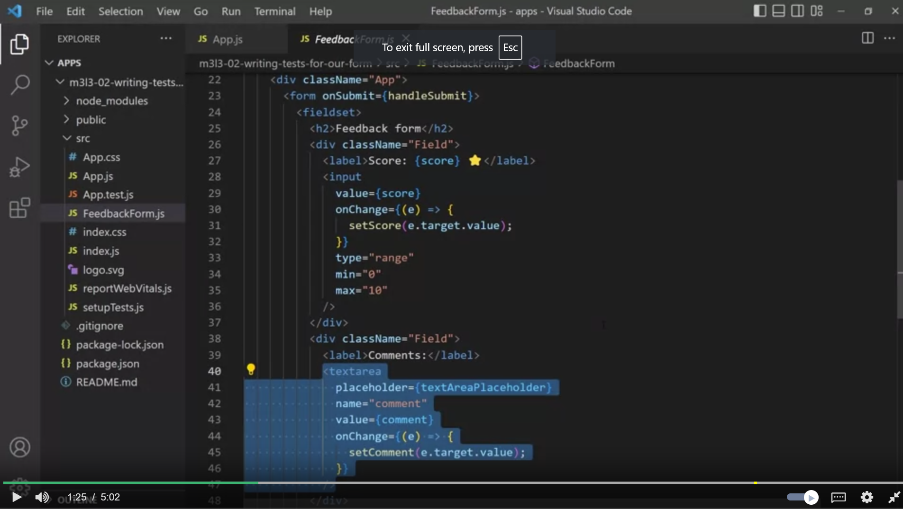

**Example of :-**

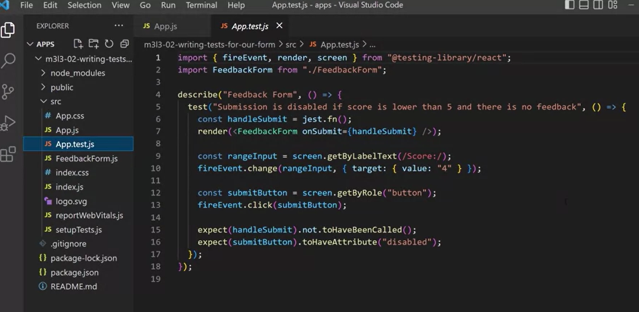

**React Testing with Jest:-**

import { fireEvent, render, screen } from "@testing-library/react";

import FeedbackForm from "./FeedbackForm";

describe("Feedback Form", () => {

  test("User is able to submit the form if the score is lower than 5 and additional feedback is provided", () => {

    const score = "3";

    const comment = "The pizza crust was too thick";

    const handleSubmit = jest.fn();

    render(<FeedbackForm onSubmit={handleSubmit} />);

    const rangeInput = screen.getByLabelText(/Score:/);

    fireEvent.change(rangeInput, { target: { value: score } });

    const textArea = screen.getByLabelText(/Comments:/);

    fireEvent.change(textArea, { target: { value: comment } });

    const submitButton = screen.getByRole("button");

    fireEvent.click(submitButton);

    expect(handleSubmit).toHaveBeenCalledWith({

      score,

      comment,

    });

  });

  test("User is able to submit the form if the score is higher than 5, without additional feedback", () => {

    const score = "9";

    const handleSubmit = jest.fn();

    render(<FeedbackForm onSubmit={handleSubmit} />);

    const rangeInput = screen.getByLabelText(/Score:/);

    fireEvent.change(rangeInput, { target: { value: score } });

    const submitButton = screen.getByRole("button");

    fireEvent.click(submitButton);

    expect(handleSubmit).toHaveBeenCalledWith({

      score,

      comment: ""

    });

  });

});

## How to Create a Form Without Using a Library

import React, { useState } from "react";

import "./styles.css";

export default function App() {

  const [state, setState] = useState({

    email: "",

    password: ""

  });

  const handleInputChange = (event) => {

    const { name, value } = event.target;

    setState((prevProps) => ({

      ...prevProps,

      [name]: value

    }));

  };

  const handleSubmit = (event) => {

    event.preventDefault();

    console.log(state);

  };

  return (

    <div className="App">

      <form onSubmit={handleSubmit}>

        <div className="form-control">

          <label>Email</label>

          <input

            type="text"

            name="email"

            value={state.email}

            onChange={handleInputChange}

          />

        </div>

        <div className="form-control">

          <label>Password</label>

          <input

            type="password"

            name="password"

            value={state.password}

            onChange={handleInputChange}

          />

        </div>

        <div className="form-control">

          <label></label>

          <button type="submit">Login</button>

        </div>

      </form>

    </div>

  );

}

React Timesheet Application:-

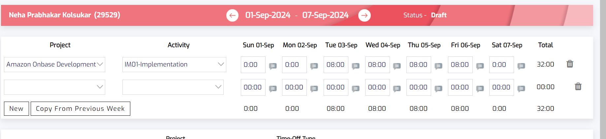

///////////FrontEnd///////////

import React, { useState, useEffect } from 'react';

const TimeSheet = () => {

  const [rows, setRows] = useState([]);

  const [projects, setProjects] = useState([]);

  // Fetch the list of projects from the API (or database)

  useEffect(() => {

    // Replace this URL with your API endpoint

    fetch('/api/projects')

      .then(response => response.json())

      .then(data => {

        setProjects(data); // Assuming data is an array of project objects

      })

      .catch(error => console.error('Error fetching projects:', error));

  }, []);

  // Add a new row with default values

  const addRow = () => {

    setRows([...rows, {

      project: '',

      activity: '',

      hours: { sun: '', mon: '', tue: '', wed: '', thu: '', fri: '', sat: '' },

      total: 0,

    }]);

  };

  // Delete a row based on the index

  const deleteRow = (index) => {

    const newRows = [...rows];

    newRows.splice(index, 1);

    setRows(newRows);

  };

  // Handle input changes for hours and calculate the total

  const handleInputChange = (index, day, value) => {

    const newRows = [...rows];

    newRows[index].hours[day] = value;

    const total = Object.values(newRows[index].hours).reduce((acc, val) => acc + Number(val || 0), 0); // Reducsed to the single value

    newRows[index].total = total;

    setRows(newRows);

  };

   // Handle dropdown changes for project and activity

  const handleSelectChange = (index, field, value) => {

    const newRows = [...rows];   //Created shalow copy and then changed it

    newRows[index][field] = value;

    setRows(newRows);

  };

   // Handle form submission

  const handleSubmit = () => {

    const dataToSubmit = rows.map(row => ({

      project: row.project,

      activity: row.activity,

      hours: row.hours,

      total: row.total,

    }));

    // Show alert on submission

    alert(JSON.stringify(dataToSubmit, null, 2));

    // Assuming the backend API endpoint to save data is `/api/submit-timesheet`

  fetch('/api/submit-timesheet', {

    method: 'POST',

    headers: {

      'Content-Type': 'application/json',

    },

    body: JSON.stringify(dataToSubmit),

  })

    .then(response => {

      if (!response.ok) {

        throw new Error('Failed to save data');

      }

      return response.json();

    })

    .then(data => {

      console.log('Data successfully saved:', data);

      alert('Data saved successfully!');

    })

    .catch(error => {

      console.error('Error submitting data:', error);

      alert('Failed to save data');

    });

  };

  return (

    <div>

      <table border="1">

        <thead>

          <tr>

            <th>Project</th>

            <th>Activity</th>

            <th>Sun</th>

            <th>Mon</th>

            <th>Tue</th>

            <th>Wed</th>

            <th>Thu</th>

            <th>Fri</th>

            <th>Sat</th>

            <th>Total</th>

            <th>Action</th>

          </tr>

        </thead>

        <tbody>

          {rows.map((row, index) => (

            <tr key={index}>

              <td>

                <select value={row.project} onChange={(e) => handleSelectChange(index, 'project', e.target.value)}>

                  <option value="">Select Project</option>

                  {projects.map((project) => (

                    <option key={project.id} value={project.name}>

                      {project.name}

                    </option>

                  ))}

                </select>

              </td>

              <td>

                <select value={row.activity} onChange={(e) => handleSelectChange(index, 'activity', e.target.value)}>

                  <option value="">Select Activity</option>

                  <option value="IM01-Implementation">IM01-Implementation</option>

                  {/* Add more activities */}

                </select>

              </td>

              {['sun', 'mon', 'tue', 'wed', 'thu', 'fri', 'sat'].map(day => (

                <td key={day}>

                  <input

                    type="number"

                    value={row.hours[day]}

                    onChange={(e) => handleInputChange(index, day, e.target.value)}

                  />

                </td>

              ))}

              <td>{row.total.toFixed(2)}</td>

              <td>

                <button onClick={() => deleteRow(index)}>🗑️</button>

              </td>

            </tr>

          ))}

        </tbody>

      </table>

      <button onClick={addRow}>Add Row</button>

      <br />

      <button onClick={handleSubmit}>Submit</button>

    </div>

  );

};

export default TimeSheet;

///////////Backend for submit API////////////////

npm install express body-parser pg

const express = require('express');

const bodyParser = require('body-parser');

const { Pool } = require('pg'); // PostgreSQL client

const app = express();

const pool = new Pool({

  user: 'dbuser',

  host: 'localhost',

  database: 'timesheet_db',

  password: 'password',

  port: 5432,

});

app.use(bodyParser.json());

// API endpoint to handle timesheet submission

app.post('/api/submit-timesheet', async (req, res) => {

  const timesheetData = req.body;

  try {

    // Assuming you have a "timesheet" table in your PostgreSQL database

    const queryText = `

      INSERT INTO timesheet (project, activity, sun, mon, tue, wed, thu, fri, sat, total)

      VALUES ($1, $2, $3, $4, $5, $6, $7, $8, $9, $10)

    `;

    // Loop through each row and save it to the database

    for (let row of timesheetData) {

      await pool.query(queryText, [

        row.project,

        row.activity,

        row.hours.sun,

        row.hours.mon,

        row.hours.tue,

        row.hours.wed,

        row.hours.thu,

        row.hours.fri,

        row.hours.sat,

        row.total

      ]);

    }

    res.status(200).send({ message: 'Timesheet successfully saved' });

  } catch (error) {

    console.error('Error saving timesheet:', error);

    res.status(500).send({ message: 'Error saving timesheet' });

  }

});

app.listen(3000, () => {

  console.log('Server is running on port 3000');

});

**Features Implemented:-**

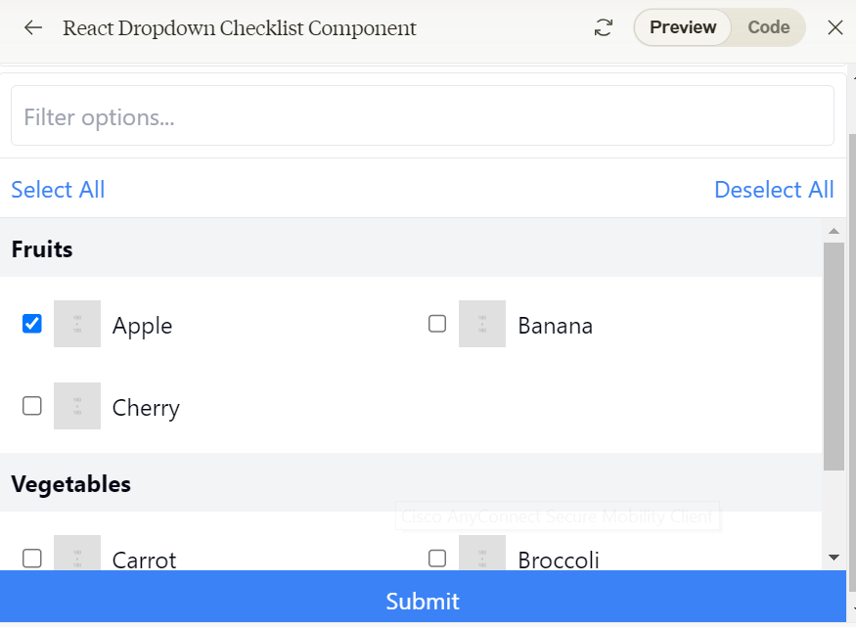

**Here's a breakdown of the key features:**

1. The component uses a list of options, each with an id, label, and image URL.
2. Users can toggle the dropdown open/closed.
3. There's a filter input to search for specific options.
4. Selected options are displayed as tags below the dropdown.
5. Each option in the dropdown shows a checkbox, image, and label.
6. Selected items can be removed by clicking an 'X' button on the tag.

Key changes:-

• Added a submit button inside the dropdown:

* The button is placed at the bottom of the dropdown.
* When clicked, it calls the handleSubmit function.

• Created a new state variable submittedOptions:

* This keeps track of the options that have been submitted.
* It's updated in the handleSubmit function.

• Added a new section to display submitted images:

* A grid layout is used to display the images of submitted options.
* The images are shown below the "Selected Items" section.

• Modified the handleSubmit function:

* It updates the submittedOptions state with the current selectedOptions.
* It closes the dropdown after submission.

Additional features:-

• Integrating it with a backend API

• Adding more complex filtering or sorting options

• Implementing additional features or customizations

• Optimizing performance for large datasets

import React, { useState, useEffect, useRef } from 'react';

import { Check, ChevronDown, ChevronUp, X, Loader } from 'lucide-react';

const groupedOptions = [

  {

    group: 'Fruits',

    options: [

      { id: 1, label: 'Apple', image: '/api/placeholder/100/100' },

      { id: 2, label: 'Banana', image: '/api/placeholder/100/100' },

      { id: 3, label: 'Cherry', image: '/api/placeholder/100/100' },

    ]

  },

  {

    group: 'Vegetables',

    options: [

      { id: 4, label: 'Carrot', image: '/api/placeholder/100/100' },

      { id: 5, label: 'Broccoli', image: '/api/placeholder/100/100' },

      { id: 6, label: 'Spinach', image: '/api/placeholder/100/100' },

    ]

  },

];

const DropdownChecklist = () => {

  const [isOpen, setIsOpen] = useState(false);

  const [selectedOptions, setSelectedOptions] = useState([]);

  const [submittedOptions, setSubmittedOptions] = useState([]);

  const [filter, setFilter] = useState('');

  const [loading, setLoading] = useState(true);

  const dropdownRef = useRef(null);

  useEffect(() => {

    // Simulating asynchronous data fetching

    const timer = setTimeout(() => {

      setLoading(false);

    }, 1500);

    return () => clearTimeout(timer);

  }, []);

  const toggleOption = (option) => {

    setSelectedOptions(prev =>

      prev.some(item => item.id === option.id)

        ? prev.filter(item => item.id !== option.id)

        : [...prev, option]

    );

  };

  const handleSelectAll = () => {

    const allOptions = groupedOptions.flatMap(group => group.options);

    setSelectedOptions(allOptions);

  };

  const handleDeselectAll = () => {

    setSelectedOptions([]);

  };

  const filteredGroups = groupedOptions.map(group => ({

    ...group,

    options: group.options.filter(option =>

      option.label.toLowerCase().includes(filter.toLowerCase())

    )

  })).filter(group => group.options.length > 0);

  const handleSubmit = () => {

    setSubmittedOptions(selectedOptions);

    setIsOpen(false);

  };

  const handleKeyDown = (e) => {

    if (e.key === 'Escape') {

      setIsOpen(false);

    }

  };

  useEffect(() => {

    if (isOpen) {

      dropdownRef.current?.querySelector('input')?.focus();

    }

  }, [isOpen]);

  return (

    <div className="w-full max-w-2xl relative" onKeyDown={handleKeyDown}>

      <button

        onClick={() => setIsOpen(!isOpen)}

        className="w-full p-2 flex justify-between items-center border rounded"

      >

        <span>{selectedOptions.length} selected</span>

        {isOpen ? <ChevronUp size={20} /> : <ChevronDown size={20} />}

      </button>

//If isopen is true then below dropdown code will be displayed else do not show anything the below code

      {isOpen && (

        <div ref={dropdownRef} className="absolute w-full mt-1 border rounded bg-white shadow-lg z-10">

          <div className="p-2 border-b">

            <input

              type="text"

              placeholder="Filter options..."

              value={filter}

              onChange={(e) => setFilter(e.target.value)}

              className="w-full p-2 border rounded"

            />

          </div>

          <div className="p-2 border-b flex justify-between">

            <button onClick={handleSelectAll} className="text-blue-500 hover:text-blue-700">Select All</button>

            <button onClick={handleDeselectAll} className="text-blue-500 hover:text-blue-700">Deselect All</button>

          </div>

          {loading ? (

            <div className="flex justify-center items-center h-40">

              <Loader className="animate-spin" size={24} />

            </div>

          ) : (

            <div className="max-h-60 overflow-auto">

              {filteredGroups.map(group => (

                <div key={group.group}>

                  <div className="p-2 font-bold bg-gray-100">{group.group}</div>

                  <ul className="grid grid-cols-2 gap-2 p-2">

                    {group.options.map(option => (

                      <li

                        key={option.id}

                        className="flex items-center p-2 hover:bg-gray-100 cursor-pointer rounded"

                        onClick={() => toggleOption(option)}

                      >

                        <input

                          type="checkbox"

                          checked={selectedOptions.some(item => item.id === option.id)}

                          onChange={() => {}}

                          className="mr-2"

                        />

                        <img src={option.image} alt={option.label} className="w-8 h-8 mr-2" />

                        <span className="flex-grow">{option.label}</span>

                      </li>

                    ))}

                  </ul>

                </div>

              ))}

            </div>

          )}

          <button

            onClick={handleSubmit}

            className="w-full p-2 bg-blue-500 text-white hover:bg-blue-600 transition-colors"

          >

            Submit

          </button>

        </div>

      )}

      <div className="mt-4">

        <h3 className="font-bold mb-2">Selected Items:</h3>

        <div className="flex flex-wrap gap-2">

          {selectedOptions.map(option => (

            <div key={option.id} className="flex items-center bg-blue-100 rounded p-1">

              <img src={option.image} alt={option.label} className="w-6 h-6 mr-1" />

              <span>{option.label}</span>

              <button

                onClick={() => toggleOption(option)}

                className="ml-1 text-red-500 hover:text-red-700"

              >

                <X size={16} />

              </button>

            </div>

          ))}

        </div>

      </div>

      <div className="mt-4">

        <h3 className="font-bold mb-2">Submitted Images:</h3>

        <div className="grid grid-cols-4 gap-2">

          {submittedOptions.map(option => (

            <img

              key={option.id}

              src={option.image}

              alt={option.label}

              className="w-full h-auto rounded"

            />

          ))}

        </div>

      </div>

    </div>

  );

};

export default DropdownChecklist;

**Filter Code Snippets:-**

<input

              type="text"

              placeholder="Filter options..."

              value={filter}

              onChange={(e) => setFilter(e.target.value)}

              className="w-full p-2 border rounded"

            />

**SetTimeout function call:-**

function asyncTask(callback) {

  setTimeout(() => {

      console.log("Task complete");

      callback();

  }, 1000);

}

asyncTask(() => console.log("Next step"));

After 1 second, the code inside the arrow function () => { console.log("Task complete"); callback(); } will be executed.

callback is =====🡺 () => console.log("Next step")

**Comparison of most commonly used patterns in Vanilla JS and React:-**

|  |  |  |
| --- | --- | --- |
| **Pattern** | **Vanilla JavaScript** | **React Component** |
| **Filter Search (Simple)** | js let input = document.getElementById('search'); input.addEventListener('input', function() { let filter = input.value.toLowerCase();  let items = document.querySelectorAll('.item'); items.forEach(item => item.style.display = item.textContent.toLowerCase().includes(filter) ? 'block' : 'none'); }); | jsx function FilterList() { const [filter, setFilter] = useState(''); const items = ['Apple', 'Banana']; return (<><input value={filter} onChange={(e) => setFilter(e.target.value)} /><ul>{items.filter(item => item.toLowerCase().includes(filter)).map((item, i) => <li key={i}>{item}</li>)}</ul></>); } |
| **Dropdown Menu** | js let dropdown = document.getElementById('dropdown'); dropdown.addEventListener('change', function() { console.log(this.value); }); | jsx function Dropdown() { return (<select onChange={(e) => console.log(e.target.value)}><option>Option 1</option><option>Option 2</option></select>); } |
| **Modal (Open/Close)** | js let modal = document.getElementById('modal'); let btn = document.getElementById('openModal'); btn.addEventListener('click', () => modal.style.display = 'block'); let closeBtn = document.getElementById('closeModal'); closeBtn.addEventListener('click', () => modal.style.display = 'none'); | jsx function Modal() { const [isOpen, setIsOpen] = useState(false); return (<>{isOpen && <div id="modal"><button onClick={() => setIsOpen(false)}>Close</button></div>}<button onClick={() => setIsOpen(true)}>Open Modal</button></>); } |
| **Toggle Switch** | js let toggle = document.getElementById('toggle'); toggle.addEventListener('change', () => { console.log(toggle.checked); }); | jsx function ToggleSwitch() { const [checked, setChecked] = useState(false); return (<><input type="checkbox" checked={checked} onChange={() => setChecked(!checked)} /><p>{checked ? 'On' : 'Off'}</p></>); } |
| **Sidebar (Open/Close)** | js let sidebar = document.getElementById('sidebar'); let toggleSidebar = document.getElementById('toggleSidebar'); toggleSidebar.addEventListener('click', () => sidebar.classList.toggle('open')); | jsx function Sidebar() { const [isOpen, setIsOpen] = useState(false); return (<><button onClick={() => setIsOpen(!isOpen)}>Toggle Sidebar</button>{isOpen && <div id="sidebar">Sidebar Content</div>}</>); } |
| **Accordion (Expand/Collapse)** | js let acc = document.querySelectorAll('.accordion'); acc.forEach(item => item.addEventListener('click', function() { this.classList.toggle('active'); this.nextElementSibling.style.display = this.classList.contains('active') ? 'block' : 'none'; })); | jsx function Accordion() { const [isActive, setIsActive] = useState(false); return (<><div onClick={() => setIsActive(!isActive)} className={`accordion ${isActive ? 'active' : ''}`}>Accordion</div>{isActive && <div>Content</div>}</>); } |
| **Tabs (Switch Content)** | js let tabs = document.querySelectorAll('.tab'); tabs.forEach(tab => tab.addEventListener('click', function() { document.querySelector('.active').classList.remove('active'); this.classList.add('active'); let content = document.querySelectorAll('.content'); content.forEach(c => c.style.display = 'none'); document.getElementById(this.dataset.content).style.display = 'block'; })); | jsx function Tabs() { const [activeTab, setActiveTab] = useState('tab1'); return (<><button onClick={() => setActiveTab('tab1')}>Tab 1</button><button onClick={() => setActiveTab('tab2')}>Tab 2</button><div>{activeTab === 'tab1' ? <div>Content 1</div> : <div>Content 2</div>}</div></>); } |
| **Tooltip (Hover)** | js let tooltip = document.getElementById('tooltip'); tooltip.addEventListener('mouseover', function() { let tip = document.createElement('div'); tip.textContent = 'Tooltip Content'; document.body.appendChild(tip); }); tooltip.addEventListener('mouseout', function() { document.body.removeChild(tip); }); | jsx function Tooltip() { const [visible, setVisible] = useState(false); return (<><div onMouseOver={() => setVisible(true)} onMouseOut={() => setVisible(false)}>Hover me{visible && <div>Tooltip Content</div>}</div></>); } |
| **Routing (Simple)** | html <a href="/home.html">Home</a> <a href="/about.html">About</a> | jsx import { BrowserRouter as Router, Route, Link } from 'react-router-dom'; function App() { return (<Router><nav><Link to="/">Home</Link><Link to="/about">About</Link></nav><Route path="/" component={Home} /><Route path="/about" component={About} /></Router>); } |
| **Sticky Header on Scroll** | js window.addEventListener('scroll', function() { let header = document.getElementById('header'); if (window.scrollY > 50) { header.classList.add('sticky'); } else { header.classList.remove('sticky'); } }); | jsx function StickyHeader() { useEffect(() => { const handleScroll = () => { const header = document.getElementById('header'); if (window.scrollY > 50) header.classList.add('sticky'); else header.classList.remove('sticky'); }; window.addEventListener('scroll', handleScroll); return () => window.removeEventListener('scroll', handleScroll); }, []); return (<header id="header">Header</header>); } |
| **Lazy Loading (Image)** | html <img src="placeholder.jpg" data-src="actual.jpg" class="lazyload"> | jsx function LazyImage() { return <img src="placeholder.jpg" data-src="actual.jpg" className="lazyload" loading="lazy" />; } |
|  | js let images = document.querySelectorAll('.lazyload'); images.forEach(img => { img.src = img.dataset.src; }); |  |
| **Pagination** | js let itemsPerPage = 5; let currentPage = 1; let items = document.querySelectorAll('.item'); function displayItems(page) { items.forEach((item, i) => item.style.display = (i >= (page-1) * itemsPerPage && i < page * itemsPerPage) ? 'block' : 'none'); } displayItems(currentPage); | jsx function Pagination() { const [currentPage, setCurrentPage] = useState(1); const items = ['Item 1', 'Item 2']; const itemsPerPage = 5; const totalPages = Math.ceil(items.length / itemsPerPage); return (<><ul>{items.slice((currentPage - 1) * itemsPerPage, currentPage * itemsPerPage).map(item => <li key={item}>{item}</li>)}</ul><button disabled={currentPage === 1} onClick={() => setCurrentPage(currentPage - 1)}>Prev</button><button disabled={currentPage === totalPages} onClick={() => setCurrentPage(currentPage + 1)}>Next</button></>); } |
| **Form Validation (Simple)** | js let form = document.getElementById('myForm'); form.addEventListener('submit', function(e) { let input = document.getElementById('name'); if (!input.value) { alert('Name is required'); e.preventDefault(); } }); | jsx function Form() { const [name, setName] = useState(''); const handleSubmit = (e) => { if (!name) { e.preventDefault(); alert('Name is required'); } }; return (<form onSubmit={handleSubmit}><input value={name} onChange={(e) => setName(e.target.value)} /><button type="submit">Submit</button></form>); } |
| **Counter (Increment/Decrement)** | js let count = 0; let counter = document.getElementById('counter'); let inc = document.getElementById('increment'); let dec = document.getElementById('decrement'); inc.addEventListener('click', () => counter.textContent = ++count); dec.addEventListener('click', () => counter.textContent = --count); | jsx function Counter() { const [count, setCount] = useState(0); return (<><p>{count}</p><button onClick={() => setCount(count + 1)}>Increment</button><button onClick={() => setCount(count - 1)}>Decrement</button></>); } |
| **File Upload** | <input type='file' id='fileUpload'> let fileUpload = document.getElementById('fileUpload'); fileUpload.addEventListener('change', (e) => console.log(e.target.files[0].name)); | function FileUpload() { return <input type='file' onChange={(e) => console.log(e.target.files[0].name)} />; } |
| **Password Strength Meter** | <input type='password' id='password'> document.getElementById('password').addEventListener('input', (e) => console.log('Strength:', e.target.value.length)); | function PasswordMeter() { const [password, setPassword] = useState(''); return (<><input type='password' value={password} onChange={(e) => setPassword(e.target.value)} /><p>Strength: {password.length}</p></>); } |
| **Scroll to Top Button** | <button id='scrollBtn'>Scroll to Top</button> document.getElementById('scrollBtn').addEventListener('click', () => window.scrollTo({ top: 0, behavior: 'smooth' })); | function ScrollToTop() { return <button onClick={() => window.scrollTo({ top: 0, behavior: 'smooth' })}>Scroll to Top</button>; } |
| **Progress Bar** | <progress id='progressBar' max='100' value='50'></progress> let progressBar = document.getElementById('progressBar'); progressBar.value = 75; | function ProgressBar({ value }) { return <progress max='100' value={value}></progress>; } |
| **Alert Pop-up** | alert('This is an alert!'); | function AlertPopup() { alert('This is an alert!'); return null; } |
| **Notification (Snackbar)** | <div id='snackbar'>This is a notification</div> let snackbar = document.getElementById('snackbar'); snackbar.style.display = 'block'; setTimeout(() => snackbar.style.display = 'none', 3000); | function Notification() { const [show, setShow] = useState(true); useEffect(() => { setTimeout(() => setShow(false), 3000); }, []); return show && <div>This is a notification</div>; } |
| **Timer (Countdown)** | let time = 60; let timer = setInterval(() => { time--; console.log(time); if (time === 0) clearInterval(timer); }, 1000); | function Countdown() { const [time, setTime] = useState(60); useEffect(() => { if (time > 0) { const timer = setTimeout(() => setTime(time - 1), 1000); return () => clearTimeout(timer); } }, [time]); return <div>{time}</div>; } |
| **Carousel/Slider** | <div class='slide' id='slide1'></div><div class='slide' id='slide2'></div> let currentSlide = 0; let slides = document.querySelectorAll('.slide'); setInterval(() => { slides[currentSlide].style.display = 'none'; currentSlide = (currentSlide + 1) % slides.length; slides[currentSlide].style.display = 'block'; }, 3000); | function Carousel() { const [currentSlide, setCurrentSlide] = useState(0); const slides = ['slide1', 'slide2']; useEffect(() => { const interval = setInterval(() => setCurrentSlide((currentSlide + 1) % slides.length), 3000); return () => clearInterval(interval); }, [currentSlide]); return <div>{slides[currentSlide]}</div>; } |
| **Collapsible Menu** | let menu = document.getElementById('menu'); menu.addEventListener('click', () => menu.classList.toggle('open')); | function CollapsibleMenu() { const [isOpen, setIsOpen] = useState(false); return (<><button onClick={() => setIsOpen(!isOpen)}>Toggle Menu</button>{isOpen && <div>Menu Items</div>}</>); } |
| **Infinite Scroll (Lazy Load)** | window.addEventListener('scroll', () => { if (window.innerHeight + window.scrollY >= document.body.offsetHeight) { console.log('Load more items'); } }); | function InfiniteScroll() { useEffect(() => { const handleScroll = () => { if (window.innerHeight + window.scrollY >= document.body.offsetHeight) console.log('Load more items'); }; window.addEventListener('scroll', handleScroll); return () => window.removeEventListener('scroll', handleScroll); }, []); return <div>Content</div>; } |
| **Password Show/Hide Toggle** | <input type='password' id='password'> <button id='togglePassword'>Show</button> document.getElementById('togglePassword').addEventListener('click', () => { let input = document.getElementById('password'); input.type = input.type === 'password' ? 'text' : 'password'; }); | function PasswordToggle() { const [show, setShow] = useState(false); return (<><input type={show ? 'text' : 'password'} /><button onClick={() => setShow(!show)}>{show ? 'Hide' : 'Show'}</button></>); } |
| **Drag and Drop** | <div id='dropZone' ondrop='drop(event)' ondragover='allowDrop(event)'>Drop here</div> function allowDrop(e) { e.preventDefault(); } function drop(e) { e.preventDefault(); let data = e.dataTransfer.getData('text'); console.log('Dropped: ', data); } | function DragAndDrop() { const handleDrop = (e) => { e.preventDefault(); let data = e.dataTransfer.getData('text'); console.log('Dropped:', data); }; return <div onDrop={handleDrop} onDragOver={(e) => e.preventDefault()}>Drop here</div>; } |
| **Dynamic Form Fields** | <button id='addField'>Add Field</button> <div id='form'></div> document.getElementById('addField').addEventListener('click', () => { let field = document.createElement('input'); document.getElementById('form').appendChild(field); }); | function DynamicForm() { const [fields, setFields] = useState([]); return (<><button onClick={() => setFields([...fields, ''])}>Add Field</button>{fields.map((_, i) => <input key={i} />)}</>); } |
| **Scrollspy (Highlight Active Section)** | window.addEventListener('scroll', () => { let sections = document.querySelectorAll('section'); sections.forEach(section => { let top = section.offsetTop; if (window.scrollY >= top - 50) document.querySelector('a[href="#' + section.id + '"]').classList.add('active'); else document.querySelector('a[href="#' + section.id + '"]').classList.remove('active'); }); }); | function Scrollspy() { useEffect(() => { const handleScroll = () => { let sections = document.querySelectorAll('section'); sections.forEach(section => { let top = section.offsetTop; if (window.scrollY >= top - 50) { document.querySelector(`a[href='#${section.id}']`).classList.add('active'); } else { document.querySelector(`a[href='#${section.id}']`).classList.remove('active'); } }); }; window.addEventListener('scroll', handleScroll); return () => window.removeEventListener('scroll', handleScroll); }, []); return <nav>...</nav>; } |
| **Accordion with Multiple Sections** | let accordions = document.querySelectorAll('.accordion'); accordions.forEach(acc => acc.addEventListener('click', function() { this.classList.toggle('active'); let content = this.nextElementSibling; content.style.display = this.classList.contains('active') ? 'block' : 'none'; })); | function Accordion() { const [activeIndex, setActiveIndex] = useState(null); const handleAccordionClick = (i) => setActiveIndex(activeIndex === i ? null : i); return (<>{[0, 1, 2].map(i => (<><button onClick={() => handleAccordionClick(i)}>Section {i + 1}</button>{activeIndex === i && <div>Content {i + 1}</div>}</>))}</>); } |

# **Idempotence: Do It Once, Do It Right (Even If You Do It 100 Times)**

In programming, some actions should behave the same way no matter how many times you do them. That’s **idempotence** — whether you call an API once or 100 times, the result is the same.

GET /user/123 HTTP/1.1

If you keep calling GET /user/123, you’ll always get the same user back. **The world of APIs relies on this principle**—it’s what keeps things predictable and safe.

**Copy to Clipboard:-**

import React, { useState, useRef } from 'react';

const CopyToClipboard = () => {

  const [text, setText] = useState('');

  const [copied, setCopied] = useState(false);

  const textAreaRef = useRef(type);

  const handleCopy = () => {

    textAreaRef.current.select();

    document.execCommand('copy');

    setCopied(true);

    setTimeout(() => setCopied(false), 2000);

  };

  return (

    <div className="p-4">

      <textarea

        ref={textAreaRef}

        value={text}

        onChange={(e) => setText(e.target.value)}

        placeholder="Enter text to copy"

        className="border p-2 mr-2 w-full"

        rows={3}

      />

      <button

        onClick={handleCopy}

        className="bg-blue-500 text-white p-2 rounded mt-2"

      >

        {copied ? 'Copied!' : 'Copy to Clipboard'}

      </button>

    </div>

  );

};

export default CopyToClipboard;

**Node.js:-**

Node:- <https://nodejs.org/docs/latest/api/events.html#passing-arguments-and-this-to-listeners>

Express:- <https://expressjs.com/en/starter/examples.html>

Node.js 🡪 <https://nodejs.org/en/learn/getting-started/introduction-to-nodejs>

|  |  |
| --- | --- |
| **Term** | **Definition** |
| Anonymous Function | A function that is not named. An anonymous function is often passed into another function as a parameter. |
| Application Server | Transforms data into dynamic content and runs the business logic, which is the data storage and transfer rules. |
| Asynchronous | A process that runs independently of other processes. |
| Callback Function | A function passed into another function as a parameter, which is then invoked inside the outer function to complete an action. Instead of blocking on asynchronous I/O operations, callback functions are used to handle results when the operations complete. |
| Database Server | A server dedicated to providing database services. |
| Dependencies | Code, usually in the form of libraries and packages, that are called from other modules and reused in a program. |
| Event-Driven | Where the flow of a program is determined by particular events such as user input. |
| Express.js | A highly configurable web framework for building applications on Node.js. |
| Framework | Generates code that cannot be altered to perform common tasks. Examples include Django, Ruby on Rails, and Express.js. |
| HTTP Server | A type of software-based server that understands URLs and hypertext transfer protocol. |
| Load | Refers to the number of concurrent users, the number of transactions, and the amount of data transferred back and forth between the clients and servers. |
| Module | Files containing related, encapsulated JavaScript code that serve a specific purpose. |
| Multi-Threaded | Where multiple tasks are executed simultaneously. |
| Node.js | A JavaScript runtime environment that runs on Google Chrome’s V8 engine. |
| Non-Blocking | Failure of a given thread does not cause failure in another, and the execution of a task is not blocked until execution of another task is completed. |
| Npm | Stands for node package manager. It is the default package manager for the Node.js runtime environment. |
| Package | A directory with one or more modules bundled together. |
| Package.json | Contains metadata information about the project, including dependencies and scripts. |
| Payload | The data transmitted between client and server. |
| Runtime Environment | Behaves similarly to a mini operating system that provides the resources necessary for an application to run. It is the infrastructure that supports the execution of a codebase. It is the hardware and software environment in which an application gets executed. Node.js is an example of a backend runtime environment. |
| Scalability | The application’s ability to dynamically handle the load as is or shrinks without it affecting the application’s performance. |
| Server.js | A file that contains the code that handles server creation. |
| Single-Threaded | Where only one command is processed at a given point of time. |
| Web Server | Ensures client requests are responded to, often using HTTP. |
| Web Service | A type of web API that communicates using HTTP requests. It is the web service in the programming interface that sends and receives requests using HTTP among web servers and the client. |

**Callback Function:-**

// Function that simulates fetching data (like an API call)

function getDataFromServer(onDataReceived) {

  // Simulating an API call with a setTimeout

  setTimeout(() => {

    const data = { name: 'Alice', age: 25 };

    onDataReceived(data); // Invoking the callback when data is ready to do further operation on it, code can be written in callback function. Replacement of Asyn and Await

  }, 2000); // Simulate a 2-second delay

}

// Passing a callback function to handle the data once it's received

getDataFromServer((receivedData) => {

  console.log('Data received:', receivedData);

});

console.log('This will print before the data is received');

### **Explanation with Clearer Names:**

1. **getDataFromServer**: This is the outer function that simulates an asynchronous operation (like fetching data from a server). It takes onDataReceived as a callback function.
2. **onDataReceived (callback)**: This is the function passed as a parameter to getDataFromServer. Once the data fetching is complete, onDataReceived is invoked to handle the data.
3. **Asynchronous Nature**: The program prints "This will print before the data is received" immediately, showing that the asynchronous operation doesn't block the rest of the code.
4. **Callback Execution**: After 2 seconds, when the "API call" completes, onDataReceived(data) is executed, which logs the received data.

This should make it clearer that:

* getDataFromServer handles the asynchronous operation.
* onDataReceived (passed as a callback) processes the result once the operation completes.

**Output:-**

This will print before the data is received

Data received: { name: 'Alice', age: 25 }

|  |  |  |
| --- | --- | --- |
| **Package/Method** | **Description** | **Code Example** |
| **http/createServer** | http package is used for establishing remote connections to a server or to create a server which listens to client. createServer - Takes a requestListener, a function which takes request and response parameters, where request is the handle to the request from the client and response is the handle to be sent to the client. | const http = require('http');  const requestListener = function(req, res) {  res.writeHead(200);  res.end('Hello, World!'); } const port = 8080; const server = http.createServer(requestListener); console.log('server listening on port: '+ port); server.listen(port); |
|  |
|  |
|  |
|  |
|  |
| **new Date()** | new Date() method returns the current date as an object. You can invoke methods on the date object to format it or change the timezone. | module.exports.getDate = function getDate() {  let aestTime = new Date().toLocaleString("en-US", {timeZone: "Australia/Brisbane"});  return aestTime; } |  |
|  |
|  |
|  |
| **import()** | The import statement is used to import modules that some other module has exported. A file that includes reusable code is known as a module. | // addTwoNos.mjs function addTwo(num) {  return num + 4; } export { addTwo }; // app.js import { addTwo } from './addTwoNos.mjs'; // Prints: 8 console.log(addTwo(4)); |  |
|  |
|  |
|  |
|  |
|  |
|  |
|  |
| **require()** | The built-in NodeJS method require() is used to incorporate external modules that are included in different files. The require() statement essentially reads and executes a JavaScript file before returning the export object. | **messages.js**  module.exports = 'Hello Programmers';  let msg = require('./messages.js'); console.log(msg); |  |

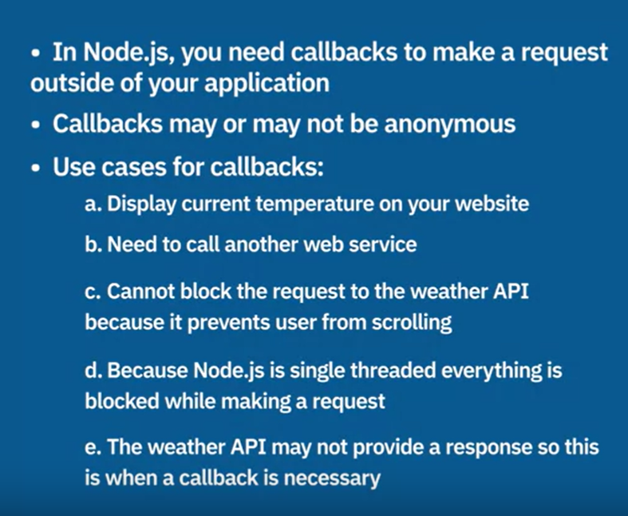

**Example of callback:- Message function is being called in setTimeout**

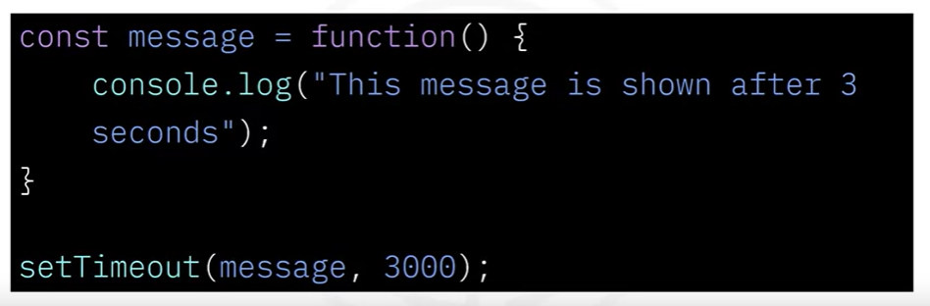

<h1>JavaScript Functions</h1>

<h2>Callback Functions</h2>

<p>The result of the calculation is:</p>

<p id="demo"></p>

<script>

function myDisplayer(something) {

  document.getElementById("demo").innerHTML = something;

}

function myCalculator(num1, num2, myCallback) {

  let sum = num1 + num2;

  myCallback(sum);

}

myCalculator(5, 5, myDisplayer);

</script>

</body>

</html>

**User-defined promise:-**

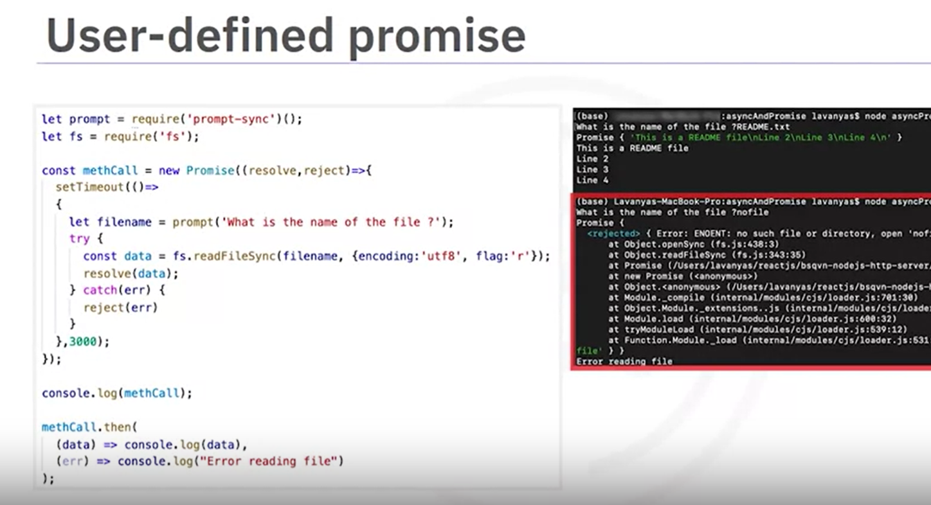

<!DOCTYPE html>

<html>

<body>

<h1>JavaScript Promise Object</h1>

<h2>The then() Method</h2>

<p id="demo"></p>

<script>

function myDisplayer(some) {

  document.getElementById("demo").innerHTML = some;

}a

let myPromise = new Promise(function(myResolve, myReject) {

  let x = 0;

// some code (try to change x to 5)

  if (x == 0) {

    myResolve("OK");

  } else {

    myReject("Error");

  }

});

myPromise.then(

  function(value) {myDisplayer(value);},

  function(error) {myDisplayer(error);}

);

</script>

</body>

</html>

**Output:-**

//Creating a promise method. The promise will get resolved when timer times out after 6 seconds.

let myPromise = new Promise((resolve,reject) => {

  setTimeout(() => {

    resolve("Promise resolved")

  },6000)})

//Console log before calling the promise

console.log("Before calling promise");

//Call the promise and wait for it to be resolved and then print a message.

myPromise.then((successMessage) => {

  console.log("From Callback " + successMessage)

})

//Console log after calling the promise

console.log("After calling promise");

Output:-

Before calling promise

After calling promise

From Callback Promise resolved

**Below are the examples of Promises VS Async/Await(Which makes it looks like a sync programs):-**

##### 1. 1 Creating a Promise

To create a Promise, you use the new Promise constructor, which takes a function with two parameters: resolve and reject. The resolve function is called when the asynchronous operation completes successfully, and the reject function is called when it fails.

// Creating a new Promise object and assigning it to the variable myPromise

const myPromise = new Promise((resolve, reject) => {

  // Simulating a condition with a boolean variable 'success'

  let success = true;

  // If the condition is true, call resolve to mark the promise as fulfilled

  if (success) {

    resolve("The operation was successful!");

  } else {

    // If the condition is false, call reject to mark the promise as rejected

    reject("The operation failed!");

  }

});

##### 1.2 Using Promises with .then() and .catch()

You can handle the resolved value or the error using .then() and .catch() methods. These methods also return Promises, allowing you to chain multiple asynchronous operations in sequence.

// Execute the promise and handle the fulfilled and rejected states

myPromise

  // Handle the resolved state of the promise

  .then((message) => {

    // This block will execute if the promise is resolved

    console.log(message); // "The operation was successful!"

  })

  // Handle the rejected state of the promise

  .catch((error) => {

    // This block will execute if the promise is rejected

    console.error(error); // "The operation failed!"

  });

##### 1.3 Example: Reading a file

Here's an example using the fs.promises module to read a file. The fs.promises module provides Promise-based methods for file system operations.

// Import the 'fs' module and use its promise-based methods

const fs = require('fs').promises;

// Read the content of the file 'example.txt' with 'utf8' encoding

fs.readFile('example.txt', 'utf8')

  // Handle the resolved state of the promise

  .then((data) => {

    // This block will execute if the file is read successfully

    console.log(data); // Print the file content to the console

  })

  // Handle the rejected state of the promise

  .catch((err) => {

    // This block will execute if there is an error reading the file

    console.error('Error reading file:', err); // Print the error message to the console

  });

#### 2. Async/Await

As you might have already learnt, Java Script is a single-threaded scripting language. It means the process can happen only sequentially and no two processes can happen simultaneously. This is a big deterrent to any language and JS solved this by introducing asynchronous programming through Promises. While Promises solved the issues with synchronous programming, nested then can compilcate the structure and readability of the code.

Async and Await are syntactic sugar over Promises, making asynchronous code look more like synchronous code, which is easier to read and write. An async function returns a Promise, and you can use await inside an async function to pause execution until a Promise is resolved or rejected.

##### 2.2 Using async and await

An async function always returns a Promise. Inside the async function, you can use the await keyword to pause execution until a Promise is resolved or rejected.

// Async function that wraps the operation

async function myAsyncFunction() {

  // Simulating a condition with a boolean variable 'success'

  let success = true;

  // If the condition is true, resolve with a success message

  if (success) {

    return "The operation was successful!";

  } else {

    // If the condition is false, throw an error to simulate rejection

    throw new Error("The operation failed!");

  }

}

// Using async function to handle Promise

async function executeAsyncFunction() {

  try {

    // Await the async function call to get the result

    const result = await myAsyncFunction();

    console.log(result); // Output the result if successful

  } catch (error) {

    console.error(error.message); // Handle and output any errors

  }

}

// Call the async function to execute

executeAsyncFunction();

#### 3. Axios Requests

Axios is a promise-based HTTP client for the browser and Node.js. It makes it easy to send asynchronous HTTP requests to REST endpoints and perform CRUD operations. Axios automatically transforms JSON data and provides a clean and simple API.

**Making a GET Request**

* Axios simplifies making HTTP GET requests. Here's how to fetch data from a public API.
* The axios.get method returns a Promise that resolves with the response object, allowing you to access the data with response.data.

// Import the axios library

const axios = require('axios');

// Using the axios.get method to make a GET request to the specified URL.

axios.get('https://api.example.com/data')

  // If the request is successful, the `.then` block is executed.

  .then(response => {

    // The response object contains the data returned from the server.

    // We log the `data` property of the response to the console.

    console.log(response.data);

  })

  // If there is an error during the request, the `.catch` block is executed.

  .catch(error => {

    // We log an error message to the console along with the error object.

    // This helps in debugging and understanding what went wrong with the request.

    console.error('Error fetching data:', error);

  });

**Making a POST Request:**

* To send data to a server, use a POST request:

// Import the axios library.

const axios = require('axios');

// Data to be sent in the POST request. This is a JavaScript object containing the user information.

const data = {

  name: 'John Doe',

  age: 30

};

// Using the axios.post method to make a POST request to the specified URL with the data object.

axios.post('https://api.example.com/users', data)

// If the request is successful, the `.then` block is executed.

  .then(response => {

// The response object contains the data returned from the server.

// We log a message along with the `data` property of the response to the console.

    console.log('User created:', response.data);

  })

  // If there is an error during the request, the `.catch` block is executed.

    .catch(error => {

    // We log an error message to the console along with the error object.

    // This helps in debugging and understanding what went wrong with the request.

    console.error('Error creating user:', error);

  });

* This code snippet demonstrates the basic usage of axios for making HTTP POST requests and handling responses and errors.

**Example: Using Async/Await with Axios**

Combining async/await with Axios provides a clean approach to handle HTTP requests:

const axios = require('axios'); // For Node.js, or include via CDN for browser

// Asynchronous function to post data to an API

async function postData() {

  try {

    // Await the response from the Axios POST request

    let response = await axios.post('https://jsonplaceholder.typicode.com/posts', {

      title: 'foo', // The title of the post

      body: 'bar',  // The body/content of the post

      userId: 1     // The user ID associated with the post

    });

    // Log the response data to the console

    console.log(response.data);

  } catch (error) {

    // If there is an error, log the error message to the console

    console.error('Error posting data:', error);

  }

}

// Call the async function to execute the request

postData();

**Below are the code snippets for Async I/O for callback programs:-**

//File reading

let fs = require('fs');

let filename1 = "courseDetails.json"

let filename2 = "courseDetails2.json"

function readfile1(filename1) {

  let data = fs.readFileSync(filename1);

  console.log("\n\n The content is saying this");

  console.log(data.toString());

}

function readfile2(filename2) {

  let data = fs.readFileSync(filename2);

  console.log("\n\n The content is saying this");

  console.log("\n\n The log says this")

}

console.log("This is reading first");

readfile1(filename1);

console.log("This is reading second");

readfile2(filename2);

//AsyncAwaitApi

const axios = require("axios").default;

const connecttoURL = async(url) => {

  const outcome = axios.get(url);

  let listofwork = (await outcome).data.work;

  listofwork.forEach((element) => {

  console.log(element.titleAut)

  });

}

console.log("Before calling connectURL");

connecttoURL();

// Function to connect to a URL and handle the response

// Async in nature

const axios = require('axios').default;

const connecttoURL = (url) => {

  const req = axios.get(URL);

  console.log(req);

  req.then(resp => {

    console.log(resp.data);

  })

  .catch(error => {

    console.log("Rejected for url" + url);

    console.error(error);

  });

}

// Creating a new Promise to handle file reading. Sync

//in nature

let promt = require('promt-sync')();

let fs = require('fs')

const metcall = new promises((resolve,reject) => {

  let filename = prompt('What is the name of the file?');

  try {

      const data = fs.readFileSync(filename, {ecoding: 'utf8', flag: 'r'});

      resolve(data);

  } catch(err){

      reject(err);

  }

});

console.log("This is where you want to write something")

metcall.then(

  (data) => console.log(data),

  (err) => console.error(err)

);

//Aync and Await Example

const axios = require('axios').default;

let url = "Some URL"

async function asynccall() {

  console.log('calling');

  const result = await axios.get(url);

  console.log(result.data);

}

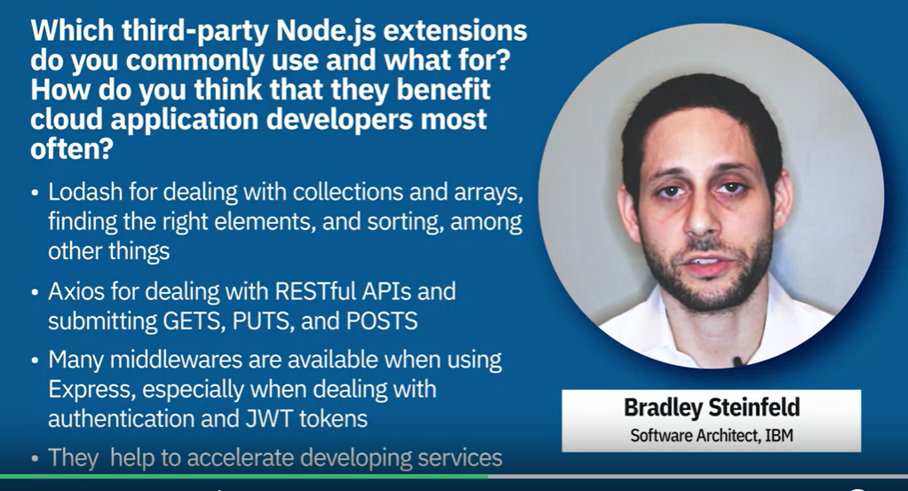

**Routing at application level:-**

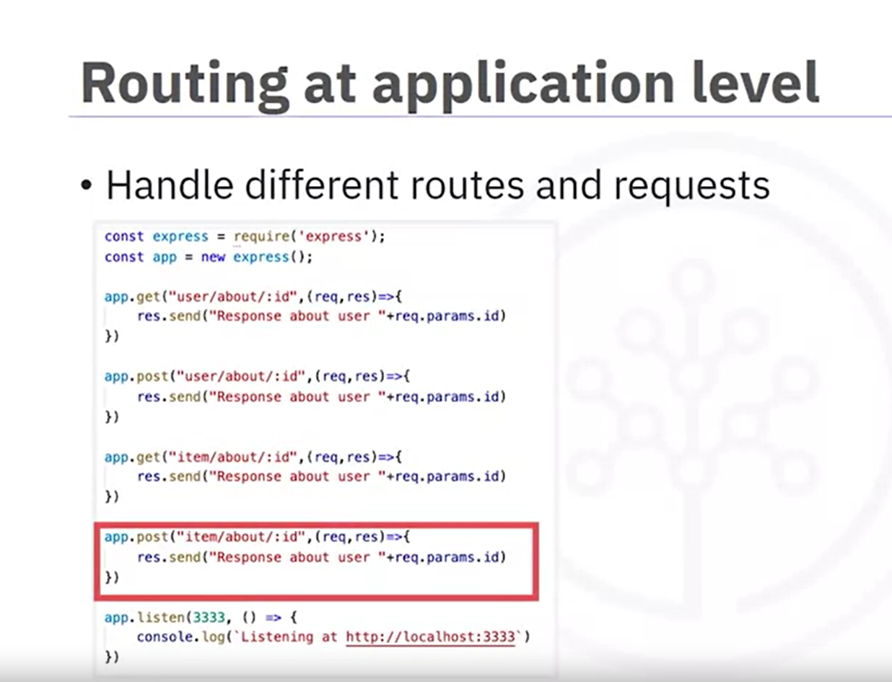

With express routers requests are handled by different routers. In below example users and item requests are handled by inidividual routers.

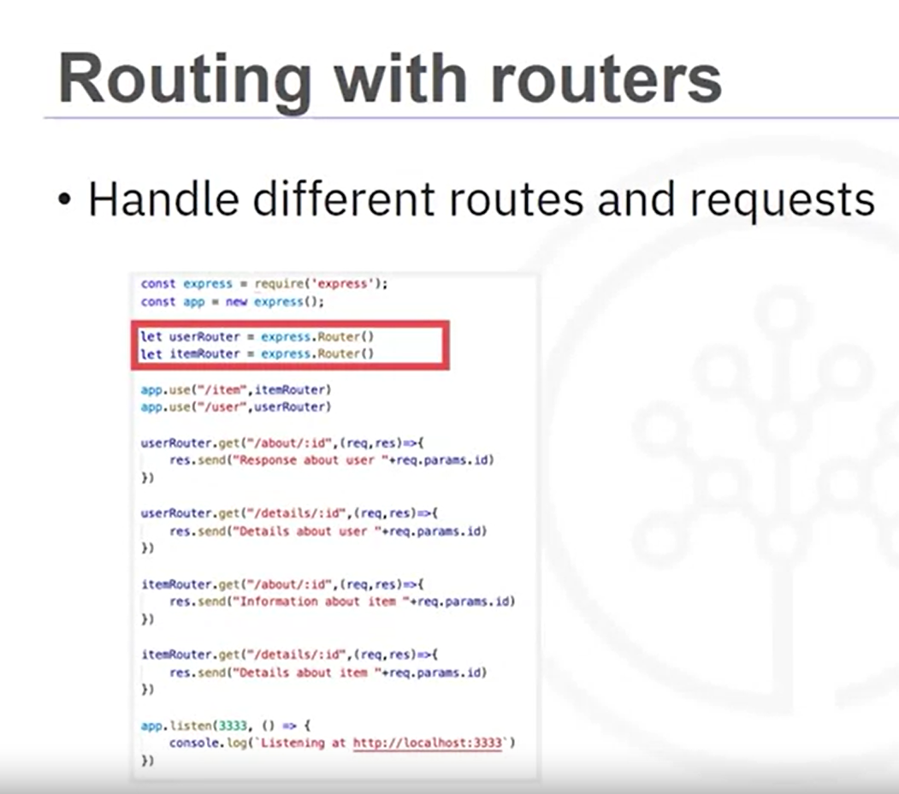

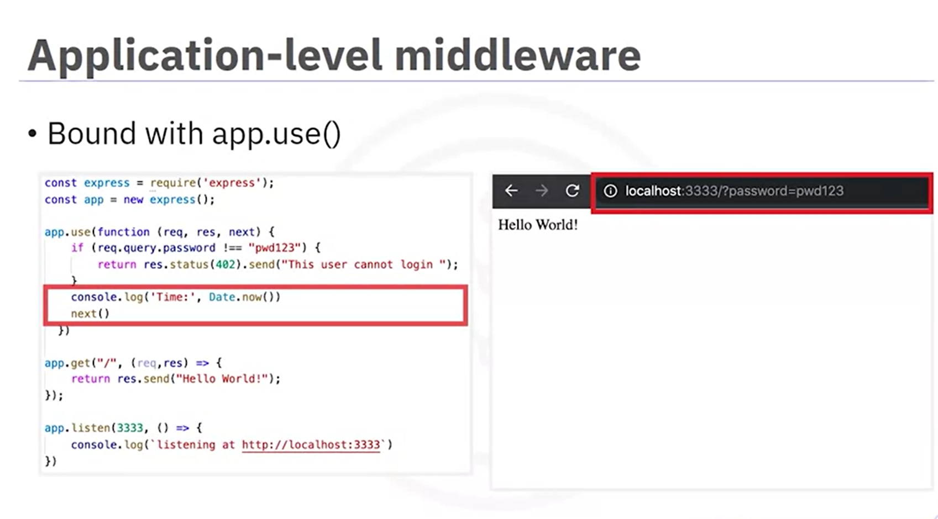





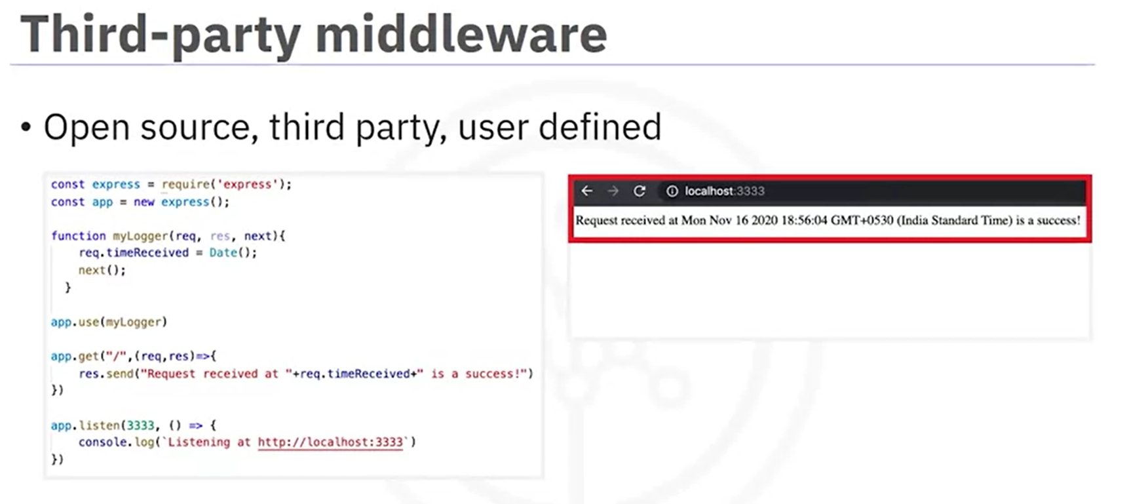

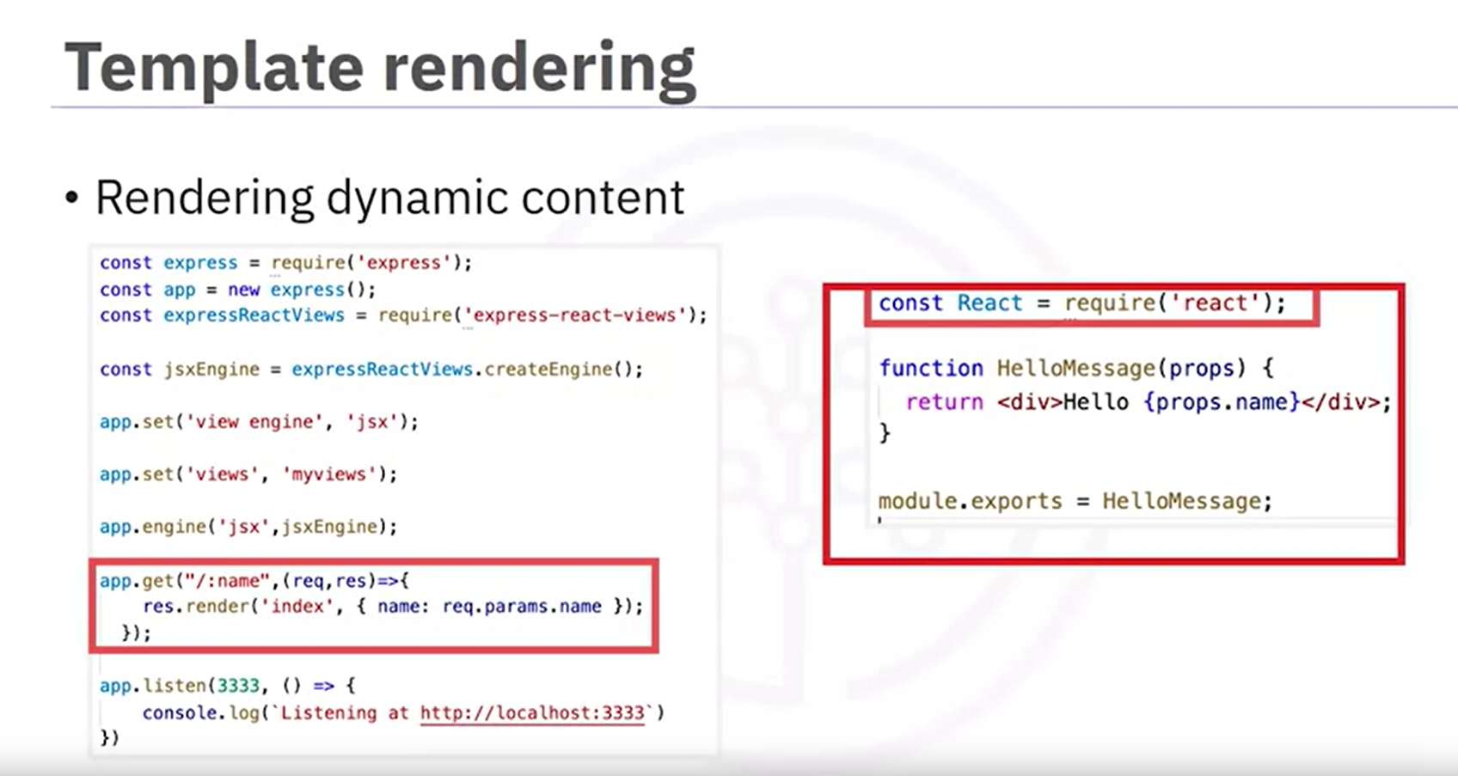

## Authentication/Middleware

The authentication process confirms a user's identity using credentials by validating who they claim to be. Authentication assures an application's security by guaranteeing that only those with valid credentials can access the system. Authentication is the responsibility of an application's backend.

Three popular authentication methods in Node.js include:

1. Session-based
2. Token-based
3. Passwordless

Let's explain a little bit about each of these methods and compare them.

### Session-based

Session-based authentication is the oldest form of authentication technology. Typically, the flow of a session is as follows.

1. The user uses their credentials to log in.
2. The login credentials are verified against the credentials in a database. The database is responsible for storing which resources can be accessed based on the session ID.
3. The server creates a session with a session ID that is a unique encrypted string. The session ID is stored in the database.
4. The session ID is also stored in the browser as a cookie.
5. When the user logs out or a specified amount of time has passed, the session ID is destroyed on both the browser and the database.

const express = require('express');

const session = require('express-session');

const app = express();

// Middleware to set up session management

app.use(session({

  secret: 'secret-key',      // Replace with a strong secret key

  resave: false,             // Whether to save the session data if there were no modifications

  saveUninitialized: true,   // Whether to save new but not modified sessions

  cookie: { secure: false }  // Set to true in production with HTTPS

}));

// POST endpoint for handling login

app.post('/login', (req, res) => {

  const { username, password } = req.body;

  // Simulated user authentication (replace with actual logic)

  if (username === 'user' && password === 'password') {

    req.session.user = username;  // Store user information in session

    res.send('Logged in successfully');

  } else {

    res.send('Invalid credentials');

  }

});

// GET endpoint for accessing dashboard

app.get('/dashboard', (req, res) => {

  if (req.session.user) {

    res.send(`Welcome ${req.session.user}`);  // Display welcome message with user's name

  } else {

    res.send('Please log in first');

  }

});

// Start the server on port 3000

app.listen(3000, () => console.log('Server running on port 3000'));

**Three popular authentication methods in Node.js include:**

1. Session-based
2. Token-based

[**https://medium.com/@techshubhu/exploring-authentication-in-node-js-session-based-vs-token-based-approaches-ac9ff9d6f391**](https://medium.com/@techshubhu/exploring-authentication-in-node-js-session-based-vs-token-based-approaches-ac9ff9d6f391)

### Session-based

Session-based authentication is the oldest form of authentication technology. Typically, the flow of a session is as follows.

1. The user uses their credentials to log in.
2. The login credentials are verified against the credentials in a database. The database is responsible for storing which resources can be accessed based on the session ID.
3. The server creates a session with a session ID that is a unique encrypted string. The session ID is stored in the database.
4. The session ID is also stored in the browser as a cookie.
5. When the user logs out or a specified amount of time has passed, the session ID is destroyed on both the browser and the database.

**Below is a code snippet demonstrating session-based authentication in an Express application:**

const express = require('express');

const session = require('express-session');

const mongoose = require('mongoose');

const bcrypt = require('bcrypt');

const app = express();

// Middleware to parse request bodies

app.use(express.urlencoded({ extended: true }));

// Connect to MongoDB

mongoose.connect('mongodb://localhost:27017/authDB', {

    useNewUrlParser: true,

    useUnifiedTopology: true,

});

// User schema and model

const userSchema = new mongoose.Schema({

    username: String,

    password: String,

});

const User = mongoose.model('User', userSchema);

// Session middleware

app.use(session({

    secret: 'your_secret_key',

    resave: false,

    saveUninitialized: true,

}));

// Register route

app.post('/register', async (req, res) => {

    const { username, password } = req.body;

    const hashedPassword = await bcrypt.hash(password, 10);

    const newUser = new User({ username, password: hashedPassword });

    await newUser.save();

    res.send('User registered!');

});

// Login route

app.post('/login', async (req, res) => {

    const { username, password } = req.body;

    const user = await User.findOne({ username });

    if (user && await bcrypt.compare(password, user.password)) {

        req.session.user = user; // Store user info in session

        res.send('Login successful!');

    } else {

        res.send('Invalid credentials');

    }

});

// Protected route

app.get('/dashboard', (req, res) => {

    if (req.session.user) {

        res.send(`Welcome, ${req.session.user.username}`);

    } else {

        res.status(401).send('Unauthorized');

    }

});

// Logout route

app.post('/logout', (req, res) => {

    req.session.destroy(err => {

        if (err) {

            return res.status(500).send('Could not log out');

        }

        res.send('Logout successful!');

    });

});

// Start the server

app.listen(3000, () => {

    console.log('Server running on http://localhost:3000');

});

### 2. Token-Based Authentication (JWT) with MongoDB

Here’s how to implement token-based authentication using MongoDB:

const express = require('express');

const jwt = require('jsonwebtoken');

const mongoose = require('mongoose');

const bcrypt = require('bcrypt');

const app = express();

const users = [];

// Middleware to parse request bodies

app.use(express.json());

// Connect to MongoDB

mongoose.connect('mongodb://localhost:27017/authDB', {

    useNewUrlParser: true,

    useUnifiedTopology: true,

});

// User schema and model

const userSchema = new mongoose.Schema({

    username: String,

    password: String,

});

const User = mongoose.model('User', userSchema);

// Secret key for JWT

const secretKey = 'your_secret_key';

// Register route

app.post('/register', async (req, res) => {

    const { username, password } = req.body;

    const hashedPassword = await bcrypt.hash(password, 10);

    const newUser = new User({ username, password: hashedPassword });

    await newUser.save();

    res.send('User registered!');

});

// Login route

app.post('/login', async (req, res) => {

    const { username, password } = req.body;

    const user = await User.findOne({ username });

    if (user && await bcrypt.compare(password, user.password)) {

        const token = jwt.sign({ username: user.username }, secretKey, { expiresIn: '1h' });

        res.json({ token });

    } else {

        res.send('Invalid credentials');

    }

});

// Middleware to verify token

const authenticateToken = (req, res, next) => {

    const token = req.headers['authorization']?.split(' ')[1];

    if (!token) return res.sendStatus(401);

    jwt.verify(token, secretKey, (err, user) => {

        if (err) return res.sendStatus(403);

        req.user = user;

        next();

    });

};

// Protected route

app.get('/dashboard', authenticateToken, (req, res) => {

    res.send(`Welcome, ${req.user.username}`);

});

// Start the server

app.listen(3000, () => {

    console.log('Server running on http://localhost:3000');

});

### **How Middleware Works:**

Middleware functions have access to the request (req), response (res), and next function. Here’s what each one does:

* **req (request)**: Contains data about the incoming request (URL, headers, body, etc.).
* **res (response)**: Contains methods to send a response back to the client.
* **next**: A function that passes control to the next middleware function. If next() isn’t called, the request will hang and not proceed.

Middleware can:

1. Execute any code.
2. Modify the request and response objects.
3. End the request-response cycle.
4. Call the next middleware function.

### Middleware Flow Example

const express = require('express');

const app = express();

// Middleware function to log request details

function logger(req, res, next) {

    console.log(`${req.method} ${req.url} at ${new Date().toISOString()}`);

    next(); // Proceed to the next middleware or route handler

}

// Middleware function to check if user is authenticated

function isAuthenticated(req, res, next) {

    const auth = req.headers['authorization'];

    if (auth === 'secret-token') {

        next(); // If authenticated, go to the next middleware or route

    } else {

        res.status(401).json({ message: "Unauthorized" }); // End the request-response cycle with an error

    }

}

// Apply middleware globally (for all routes)

app.use(logger);

// Apply middleware for a specific route

app.get('/private', isAuthenticated, (req, res) => {

    res.send('Welcome to the private route!');

});

app.get('/public', (req, res) => {

    res.send('This is a public route');

});

app.listen(3000, () => {

    console.log('Server is running on port 3000');

});

### Explanation of the Middleware Flow:

1. **Global Logger Middleware (logger)**:
   * This middleware runs for every request.
   * It logs the request method (GET, POST, etc.) and the URL being accessed, along with the current date and time.
   * After logging, it calls next() to move on to the next middleware or the route handler.
2. **Authentication Middleware (isAuthenticated)**:
   * This middleware is applied only to the /private route.
   * It checks if the request has the header authorization set to 'secret-token'.
   * If the token is valid, it calls next() to proceed to the actual route handler.
   * If not, it sends a 401 Unauthorized response, which ends the request-response cycle.
3. **Route Handlers**:
   * /public: Anyone can access this route without any authentication middleware.
   * /private: Protected by the isAuthenticated middleware. If the request is authenticated, it proceeds to return "Welcome to the private route!".

### Example Flow:

* **Public Route**:
  + When you access /public, the logger middleware runs, logs the request, and then the route handler responds with "This is a public route".
* **Private Route**:
  + When you access /private:
    - The logger middleware runs first and logs the request.
    - Then, the isAuthenticated middleware checks if the request contains a valid token.
      * If the token is valid, the request moves to the route handler, which sends "Welcome to the private route".
      * If not, it sends a 401 Unauthorized response and stops.

### Middleware Chain:

Middleware functions form a **chain**. When a request comes in:

1. It goes through the first middleware.
2. The first middleware can modify the request, then call next().
3. The next middleware runs, and the process continues until either:
   * A middleware ends the cycle with a response (e.g., res.send() or res.status()).
   * There are no more middleware functions, in which case the request reaches the route handler.

To integrate the login functionality of your Express API (/login endpoint) with the front-end, you can modify the JavaScript to send the login form data to the /login API endpoint using fetch (or any other AJAX method) and handle the response on the front-end.

Here’s how you can modify the example to call the /login API, get the JWT token, and display the result.

### Updated Front-End (HTML + JS) to Send Login Request to Express API:

<!DOCTYPE html>

<html lang="en">

<head>

    <meta charset="UTF-8">

    <meta name="viewport" content="width=device-width, initial-scale=1.0">

    <title>Login Page Example</title>

    <style>

        body {

            font-family: Arial, sans-serif;

            margin: 0;

            padding: 0;

            display: flex;

            justify-content: center;

            align-items: center;

            height: 100vh;

            background-color: #f4f4f4;

        }

        #loginForm {

            display: none;

            background-color: white;

            padding: 20px;

            border-radius: 8px;

            box-shadow: 0 0 10px rgba(0, 0, 0, 0.1);

        }

        #loginButton {

            padding: 10px 20px;

            background-color: #007bff;

            color: white;

            border: none;

            cursor: pointer;

            border-radius: 5px;

        }

        input[type="text"], input[type="password"] {

            width: 100%;

            padding: 10px;

            margin: 10px 0;

            border-radius: 5px;

            border: 1px solid #ccc;

        }

        #submitButton {

            padding: 10px 20px;

            background-color: #28a745;

            color: white;

            border: none;

            cursor: pointer;

            border-radius: 5px;

            width: 100%;

        }

        #resultMessage {

            margin-top: 20px;

            color: #333;

        }

    </style>

</head>

<body>

    <!-- Button to show login form -->

    <button id="loginButton" onclick="showLoginForm()">Click to Login</button>

    <!-- Hidden login form -->

    <div id="loginForm">

        <h2>Login</h2>

        <form id="loginFormData">

            <label for="username">Username:</label><br>

            <input type="text" id="username" name="user" required><br>

            <label for="password">Password:</label><br>

            <input type="password" id="password" name="password" required><br>

            <button type="button" id="submitButton" onclick="submitLogin()">Login</button>

        </form>

        <div id="resultMessage"></div> <!-- To display result or error messages -->

    </div>

    <script>

        // Show login form on button click

        function showLoginForm() {

            document.getElementById('loginForm').style.display = 'block';

            document.getElementById('loginButton').style.display = 'none';

        }

        // Function to handle login form submission

        async function submitLogin() {

            // Get the form data

            const username = document.getElementById('username').value;

            const password = document.getElementById('password').value;

            // Basic validation

            if (!username || !password) {

                document.getElementById('resultMessage').innerText = "Please fill out both fields.";

                return;

            }

            // Send the login data to the API using fetch

            try {

                const response = await fetch('http://localhost:5000/login', {

                    method: 'POST',

                    headers: {

                        'Content-Type': 'application/json',

                    },

                    body: JSON.stringify({

                        user: username,

                        password: password

                    }),

                });

                // Get the response as JSON

                const data = await response.json();

                // Display success or error message

                if (response.ok) {

                    document.getElementById('resultMessage').innerText = `Login successful! Token: ${data.accessToken}`;

                } else {

                    document.getElementById('resultMessage').innerText = data.message || 'Login failed.';

                }

            } catch (error) {

                document.getElementById('resultMessage').innerText = 'Error occurred during login.';

            }

        }

    </script>

</body>

</html>

### Explanation:

1. **HTML Structure**:
   * The form now has an id="loginFormData" and an input field for the password.
   * The submit button is modified to use a button type with onclick="submitLogin()", which will trigger the login function via JavaScript.
2. **JavaScript (submitLogin() function)**:
   * **Step 1**: The function retrieves the values from the form inputs for username and password.
   * **Step 2**: Using the fetch API, it sends a POST request to the /login endpoint at http://localhost:5000/login. The data is sent in the request body in JSON format.
   * **Step 3**: If the request is successful (i.e., the response is OK), the JWT token received in the response is displayed. If there’s an error (e.g., invalid credentials or a missing field), an appropriate error message is shown.
3. **Handling Response**:
   * After a successful login, the token is displayed in the #resultMessage div.
   * If the login fails (due to incorrect credentials or any other issue), an error message is displayed instead.

### **Express Backend Recap:**

Your Express /login route should be as described in the previous code:

app.post("/login", (req, res) => {

  const user = req.body.user;

  const password = req.body.password; // Assuming you're handling password too

  if (!user || !password) {

      return res.status(404).json({ message: "Body Empty" });

  }

  // Generate JWT access token

  let accessToken = jwt.sign({

      data: user

  }, 'access', { expiresIn: 60 * 60 });

  // Store access token in session (if needed)

  req.session.authorization = {

      accessToken

  }

  // Send the access token back to the client

  return res.status(200).json({

      message: "User successfully logged in",

      accessToken: accessToken // Return the JWT token

  });

});

|  |  |  |
| --- | --- | --- |
| **Package/Method** | **Description** | **Code Example** |
| **Dependencies in `package.json`** | A dependency of **express** version between **4.0 to 5.0** will be declared as: | "dependencies":{"express":"4.x"} |
| **new express()** | Creates an express object which acts as a server | const express = require(“express”); const app = new express(); |
| application. |
|  |
| **express.listen()** | The listen method is invoked on the express object with the port number on which the server listens. The function is executed when the server starts listening. | app.listen(3333, () => {  console.log(“Listening at  http://localhost:3333) }) |
|  |
| **express.get();** | This method is meant to serve the retrieve requests to the server. The get() method is to be implemented with two parameters; the first parameter defining the end-point and the second parameter is a function taking the request-handler and response-handler. | // handles GET queries to end point /user/about/id. app.get(“user/about/:id”, (req,res)=>{  res.send(“Response about user ”  +req.params.id) }) |  |
| **express.post();** | This method is meant to serve the create requests to the server. The post() method is to be implemented with two parameters: the first parameter defines the end-point and the second parameter is a function taking the request-handler and response-handler. | // handles POST queries to the same end point. app.post(“user/about/:id”, (req,res)=>{  res.send(“Response about user ”  +req.params.id) }) |  |
| **express.use()** | This method takes middleware as a parameter. Middleware acts as a gatekeeper in the same order that it is used, before the request reaches the get() and post() handlers. The order in which the middleware is chained depends on the order in which the .use() method is used to bind them. The middleware myLogger() function takes three parameters, which are request, response, and next. You can define a method that takes these three parameters and then bind it with express.use() or router.use(). Here, you are creating middleware named myLogger and making the application use it.  The output rendered includes the time the request is received. | const express = require("express"); const app = new express(); function myLogger(req, res, next){  req.timeReceived = Date();  next(); } app.get(“/”, (req, res)=>{  res.send(“Request received at  "+req.timeReceived+“ is a success!") }) |  |
|  |
|  |
|  |
|  |
| **express.Router()** | Router-level middleware is not bound to the application. Instead, it is bound to an instance of express.Router(). You can use specific middleware for a specific route instead of having all requests going through the same middleware. Here, the route is /user and you want the request to go through the user router. Define the router, define the middleware function that the router will use and what happens next, and then you bind the application route to the router. | const express = require(“express”); const app = new express(); let userRouter = express.Router(); let itemRouter = express.Router(); userRouter.use(function (req, res, next){  console.log(“User quert time:”, Date());  next(); }) userRouter.get(“/:id”, function (req, res,  next) {  res.send(“User ”+req.params.id+ “ last  successful login ”+Date()) }) app.listen(3333, () => {  console.log(“Listening at http://localhost:3333) }) |  |
|  |
|  |
|  |
|  |
|  |
|  |
|  |
|  |
|  |
|  |
|  |
|  |
|  |
|  |
|  |
|  |
|  |
| **express.static()** | This is an example of static middleware that is used to render static HTML pages and the images from the server side. At the application level, the static files can be rendered from the cad220_staticfiles directory. Notice that the URL has only the server address and the port number followed by the filename. | const express = require(“express”); const app = new express(); app.use(express.static("cad220_staticfiles")) app.listen(3333, () => {  console.log("Listening at http://localhost:3333") }) |  |
| **jsonwebtoken.sign()** | Used for signing-in based on a generated JWT (JSON Web token) | if (uname === "user" && pwd === "password") {  return res.json({  token: jsonwebtoken.sign({ user: "user" }, JWT_SECRET),  });  } |  |
|  |
|  |
|  |
|  |
|  |
| **jsonwebtoken.verify()** | Verifies a JWT by passing the token value & the JWT secret as arguments. | const verificationStatus = jsonwebtoken.verify(tokenValue, "aVeryVerySecretString"); |  |
|  |
|  |
| **Project folder strucure** | A fairly established project structure for API's built using Express.js is: | test-project/  node_modules/  config/  db.js //Database connection and configuration  credentials.js //Passwords/API keys for external services used by your app  models/ //For mongoose schemas  items.js  prices.js  routes/ //All routes for different entities in different files  items.js  prices.js  app.js  routes.js //Require all routes in this and then require this file in  package.json |  |
|  |
|  |
|  |
|  |
|  |
|  |
|  |
|  |
|  |
|  |
|  |
|  |
|  |
|  |
|  |
|  |
|  |
|  |
|  |

const express = require('express');

const router = express.Router();

let friends = {

    "johnsmith@gamil.com": {"firstName": "John","lastName": "Doe","DOB":"22-12-1990"},

    "annasmith@gamil.com":{"firstName": "Anna","lastName": "smith","DOB":"02-07-1983"},

    "peterjones@gamil.com":{"firstName": "Peter","lastName": "Jones","DOB":"21-03-1989"}

};

// GET request: Retrieve all friends

router.get("/",(req,res)=>{

    // Send JSON response with formatted friends data

    res.send(JSON.stringify(friends,null,4));

});

// GET by specific ID request: Retrieve a single friend with email ID

router.get('/:email', function(req, res) {

    // Retrieve the email parameter from the request URL and send the corresponding friend's details

    const email = req.params.email;

    res.send(friends[email]);

});

// POST request: Add a new friend

router.post("/", function(req, res) {

    // Check if email is provided in the request body

    if (req.body.email) {

        // Create or update friend's details based on provided email

        friends[req.body.email] = {

            "firstName": req.body.firstName,

            // Add similarly for lastName

            // Add similarly for DOB

        };

    }

    // Send response indicating user addition

    res.send("The user" + (' ') + (req.body.firstName) + " Has been added!");

});

// PUT request: Update the details of a friend with email id

router.put("/:email", function(req, res) {

    // Extract email parameter from request URL

    const email = req.params.email;

    let friend = friends[email];  // Retrieve friend object associated with email

    if (friend) {  // Check if friend exists

        let DOB = req.body.DOB;

        // Add similarly for firstName

        // Add similarly for lastName

        // Update DOB if provided in request body

        if (DOB) {

            friend["DOB"] = DOB;

        }

        // Add similarly for firstName

        // Add similarly for lastName

        friends[email] = friend;  // Update friend details in 'friends' object

        res.send(`Friend with the email ${email} updated.`);

    } else {

        // Respond if friend with specified email is not found

        res.send("Unable to find friend!");

    }

});

// DELETE request: Delete a friend by email id

router.delete("/:email", (req, res) => {

    // Extract email parameter from request URL

    const email = req.params.email;

    if (email) {

        // Delete friend from 'friends' object based on provided email

        delete friends[email];

    }

    // Send response confirming deletion of friend

    res.send(`Friend with the email ${email} deleted.`);

});

module.exports=router;

// Get all books based on title

public_users.get('/title/:title', function (req, res) {

    const title = req.params.title.toLowerCase(); // Convert the title from URL to lowercase for case-insensitive matching

    let foundBooks = []; // Initialize an array to store matching books

    // Iterate through the books dictionary to find matching titles

    for (const key in books) {

        if (books.hasOwnProperty(key)) {

            const book = books[key];

            if (book.title.toLowerCase().includes(title)) {

                foundBooks.push(book); // Add matching book to the array

            }

        }

    }

    if (foundBooks.length > 0) {

        return res.status(200).json({ books: foundBooks }); // Send filtered books as JSON response

    } else {

        return res.status(404).json({ message: "No books found with the given title" }); // Send 404 if no books are found

    }

});

**What is book.reviews?**

* In your code, book.reviews is expected to be an object that holds reviews for a specific book. Each key in this object typically represents a unique identifier (like a username or user ID) for the person who submitted the review, and the value is the review data (e.g., the text of the review, ratings, etc.).

Here’s a quick example of what the reviews object might look like:

const book = {

    author: "Chinua Achebe",

    title: "Things Fall Apart",

    reviews: {

        user1: { review: "A great read!", rating: 5 },

        user2: { review: "Very insightful.", rating: 4 }

    }

};

**Using Object.keys(book.reviews)**:

* When you call Object.keys(book.reviews), it will return an array of the keys in the reviews object. In the example above, this will yield:

["user1", "user2"]

**Use Cases**:

* **Check if Reviews Exist**: You can check if any reviews are present by examining the length of the array returned by Object.keys(). For example:

if (Object.keys(book.reviews).length > 0) {

    // There are reviews for this book

}

**Iterate Over Reviews: If you want to access the individual reviews, you can loop through the keys. For example:**

const reviewKeys = Object.keys(book.reviews);

reviewKeys.forEach(key => {

    const review = book.reviews[key];

    console.log(`Review by ${key}: ${review.review} (Rating: ${review.rating})`);

});

// User registration endpoint

public_users.post('/register', function (req, res) {

    const { username, password } = req.body;

    // Check if username and password are provided

    if (!username || !password) {

        return res.status(400).json({ message: "Username and password are required." });

    }

    // Check if the username already exists

    const existingUser = users.find(user => user.username === username);

    if (existingUser) {

        return res.status(400).json({ message: "Username already exists." });

    }

    // Register the new user

    const newUser = { username, password }; // In a real application, you should hash the password

    users.push(newUser);

    return res.status(201).json({ message: "User registered successfully!" });

});

**curl -X POST http://localhost:5014/register -H "Content-Type: application/json" -d '{"username":"testuser","password":"mypassword"}**

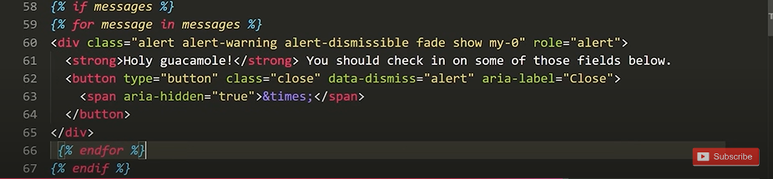

**Sample:-**

<nav class="navbar navbar-light bg-light">

    <div class="container-fluid">

        <div class="navbar-header">

            <a class="navbar-brand" href="#">Online Course</a>

        </div>

        <ul class="nav navbar-nav navbar-right">

            {% if user.is_authenticated %}

            <li>

                <a class="btn btn-link" href="#">{{ user.first_name }}({{ user.username }})</a>

                <a class="btn btn-link" href="{% url 'onlinecourse:logout' %}">Logout</a>

            </li>

            {% else %}

            <li>

                <form class="form-inline" action="{% url 'onlinecourse:login' %}" method="post">

                    {% csrf_token %}

                    <div class="input-group">

                        <input type="text" class="form-control" placeholder="Username" name="username" >

                        <input type="password" class="form-control" placeholder="Password" name="psw" >

                        <button class="btn btn-primary" type="submit">Login</button>

                        <a class="btn btn-link" href="{% url 'onlinecourse:registration' %}">Sign Up</a>

                    </div>

                </form>

            </li>

            {% endif %}

        </ul>

    </div>

</nav>

**Login Form Example:-**

<div

        onClick={(e) => {

          e.stopPropagation();

        }}

        className='modalContainer'

      >

          <form className="login_panel" style={{}} onSubmit={login}>

              <div>

              <span className="input_field">Username </span>

              <input type="text"  name="username" placeholder="Username" className="input_field" onChange={(e) => setUserName(e.target.value)}/>

              </div>

              <div>

              <span className="input_field">Password </span>

              <input name="psw" type="password"  placeholder="Password" className="input_field" onChange={(e) => setPassword(e.target.value)}/>

              </div>

              <div>

              <input className="action_button" type="submit" value="Login"/>

              <input className="action_button" type="button" value="Cancel" onClick={()=>setOpen(false)}/>

              </div>

              <a className="loginlink" href="/register">Register Now</a>

          </form>

      </div>